MegaRAC Community Edition™
  - [Build Verification Test]

Contents
1 Web UI 2
1.1 Overview 2
1.2 Event Logs 2
1.3 Dumps 3
1.4 IPMI Event Logs 4
1.5 POST Code Logs 5
1.6 Inventory and LEDs 6
1.7 Sensors 7
1.8 Advanced Log Settings 8
1.9 Network Settings 10
1.10 VLAN 11
1.11 Date and Time 12
1.12 Event Filter 13
1.13 Alert Policy 14
1.14 Lan Destinations 15
1.15 Certificates 16
1.16 LDAP 17
1.17 User management 18
1.18 Sessions 19
1.19 Policies 20
1.20 RADIUS 21
1.21 Preserve 22
1.22 Tasks 23
1.23 FRU 24
1.24 Power 25
1.25 Reboot BMC 26
1.26 Factory Default 27
1.28 Virtual Media Redirection 28
1.29 KVM 31
2 IPMI User Configuration & Privilege 32
3 Sensor 35
4 PEF & SMTP 38
5 Watchdog & FRU 45
6 User Management 51
7 Active Directory 52
8 IPMI FIREWALL 53
9 Firmware Update 55

1 Web UI

1.1 Overview
- Verify View More links for Server Information, Firmware Information, Network Information, Event Logs, and Inventory & LEDs.
- Verify Export All functionality in Event Logs.
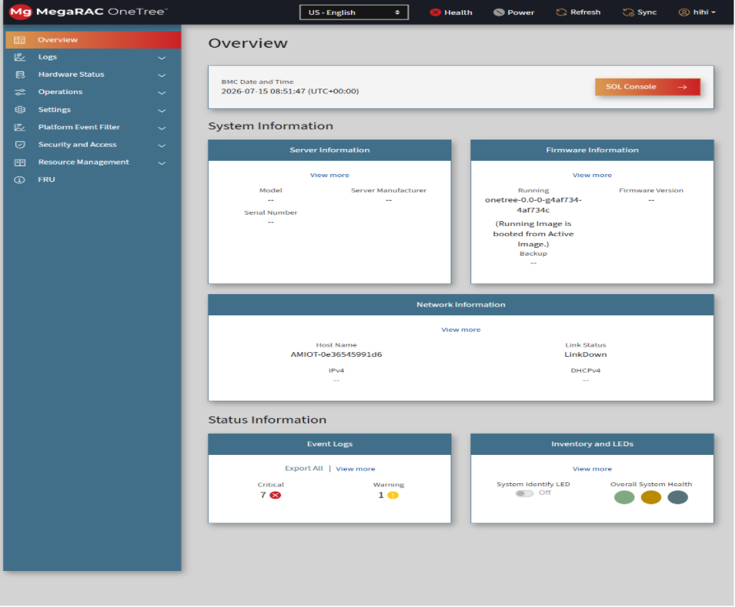

1.2 Event Logs
- Verify page loads successfully.
- Test Resolve/Unresolve operations.
- Delete an event.
- Verify Export All functionality.
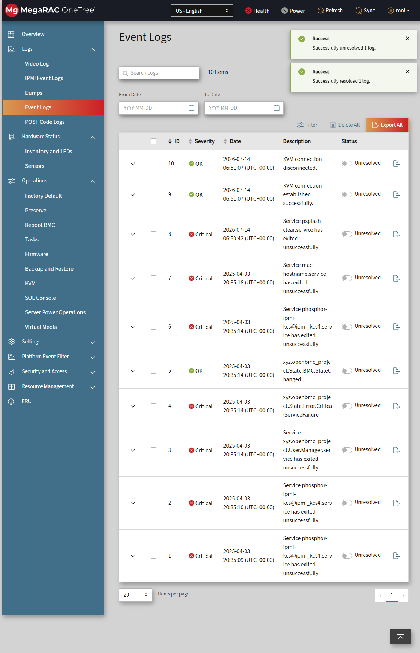

1.3 Dumps
- Create a dump.
- Verify corresponding task completes successfully in Tasks page.
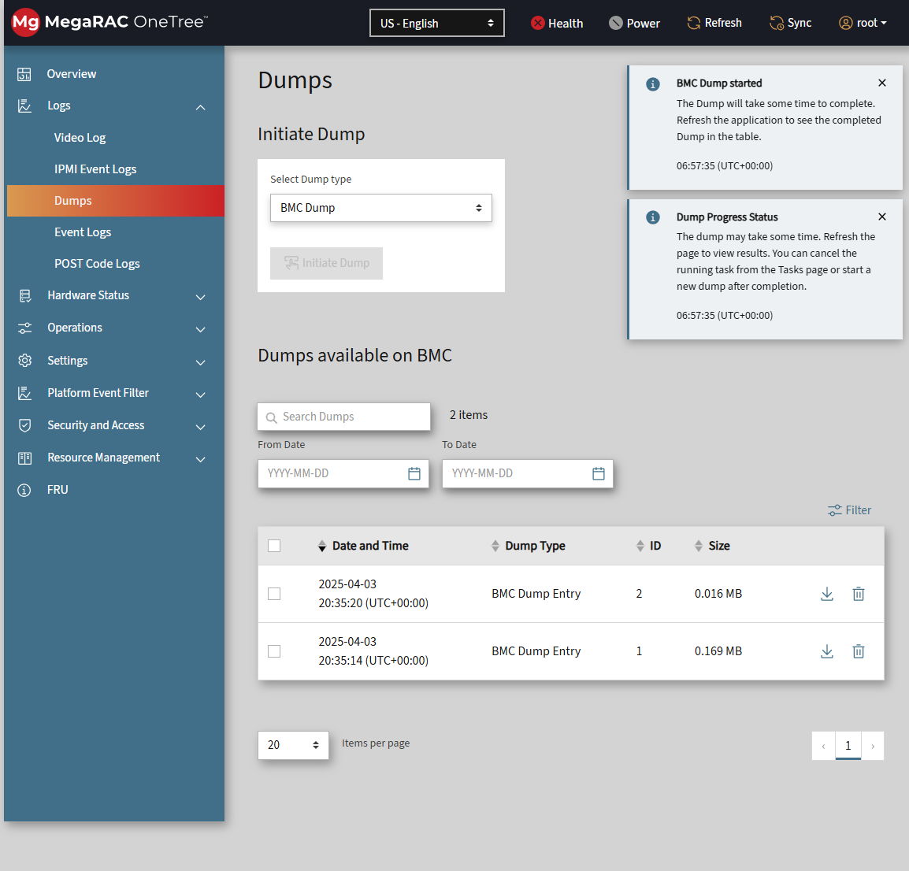

1.4 IPMI Event Logs
- Resolve/Unresolve events.
- Delete an event.
- Verify Export All functionality.
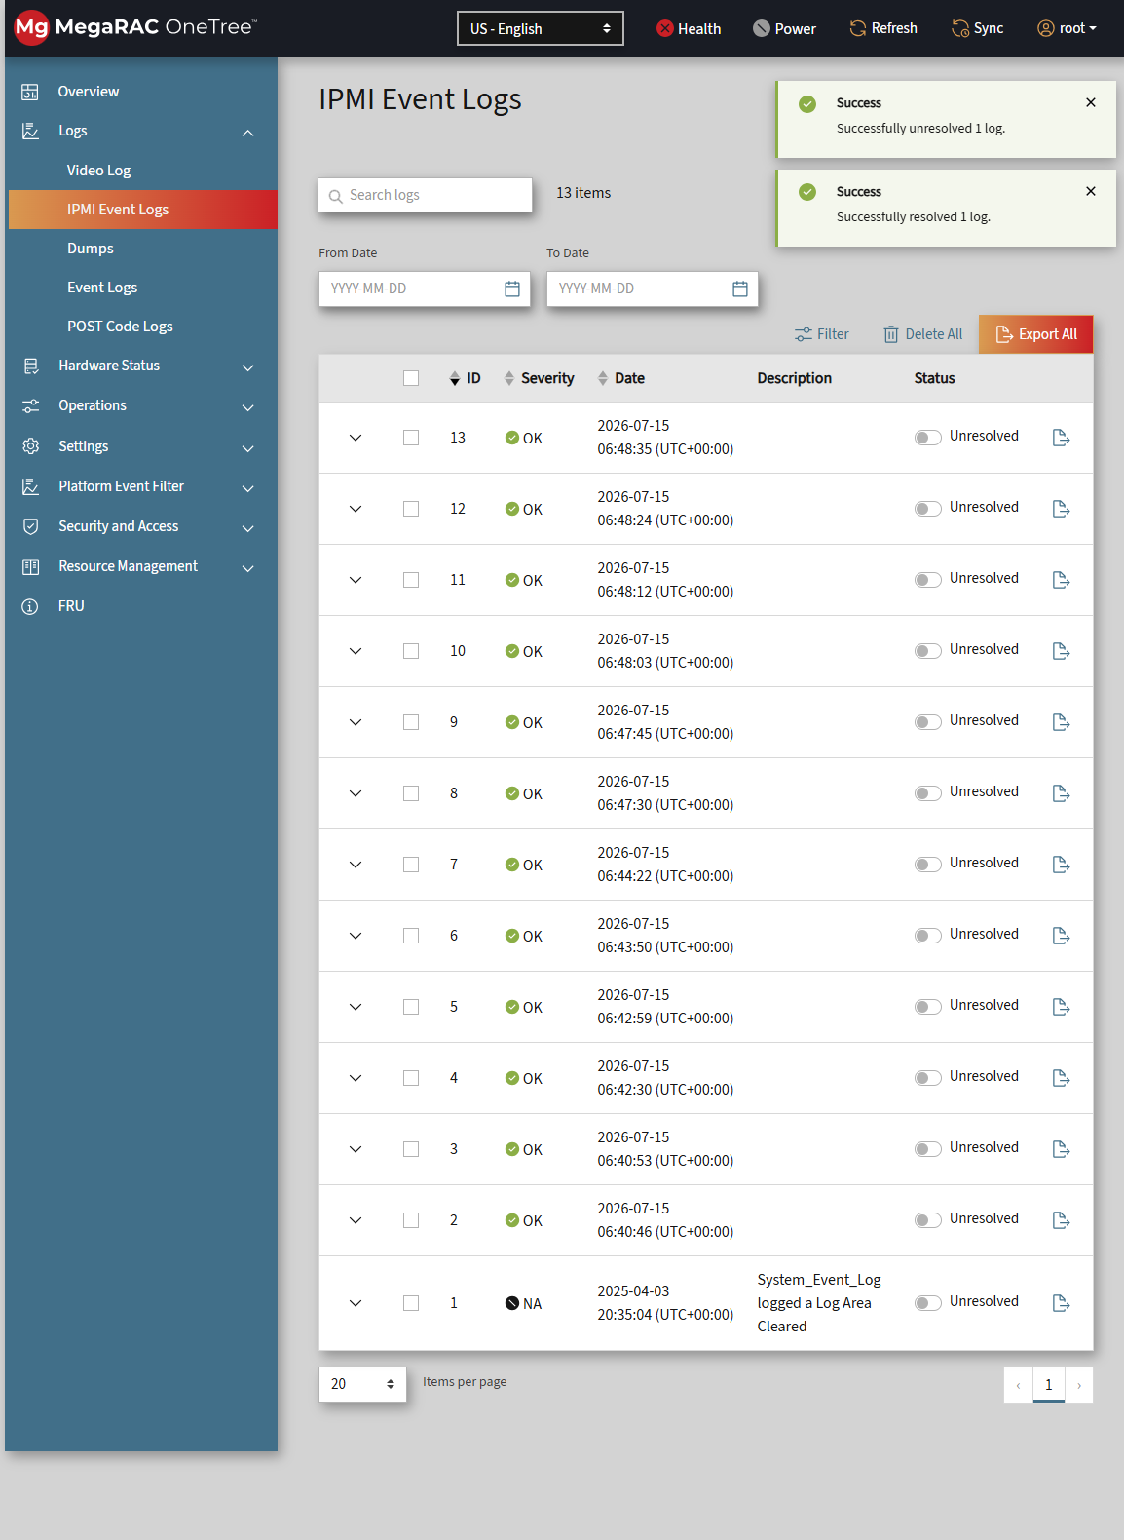

1.5 POST Code Logs
- Verify page loads and POST codes are displayed.
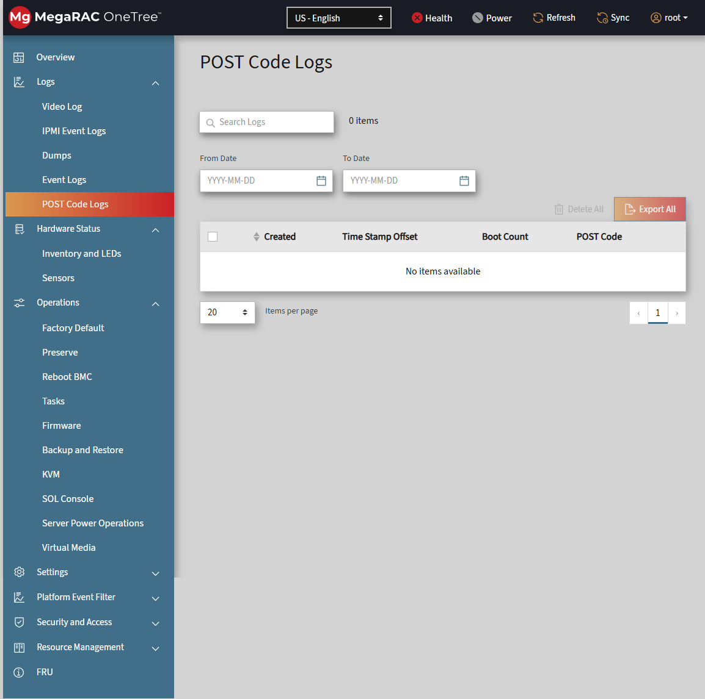

1.6 Inventory and LEDs
- Enable and disable Identify LED.
- Expand BMC Manager and Chassis sections.
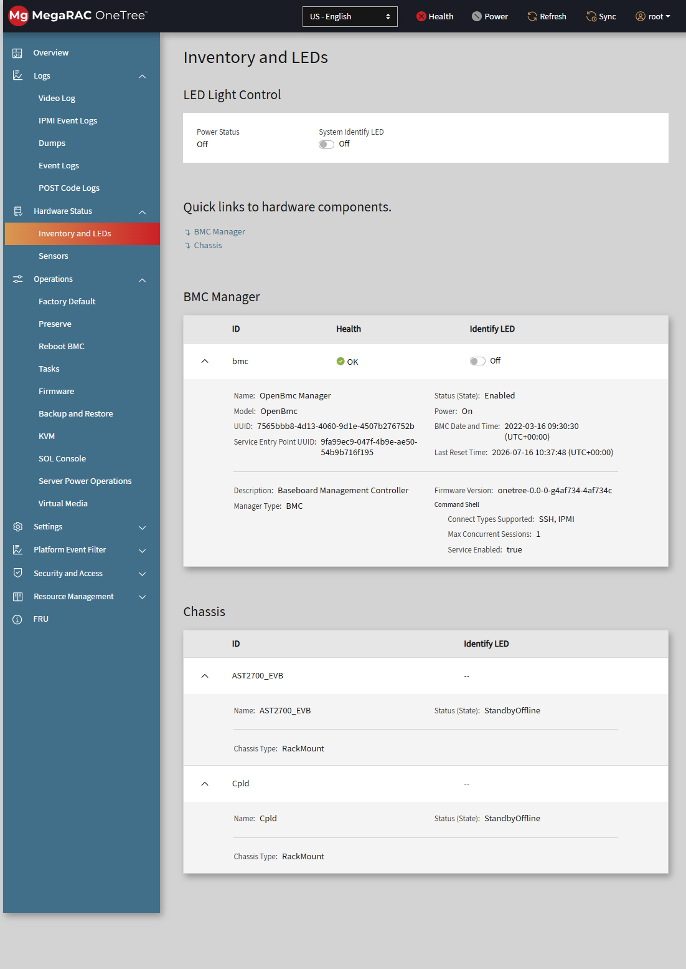

1.7 Sensors
- Modify threshold values and save changes. (Use to edit).
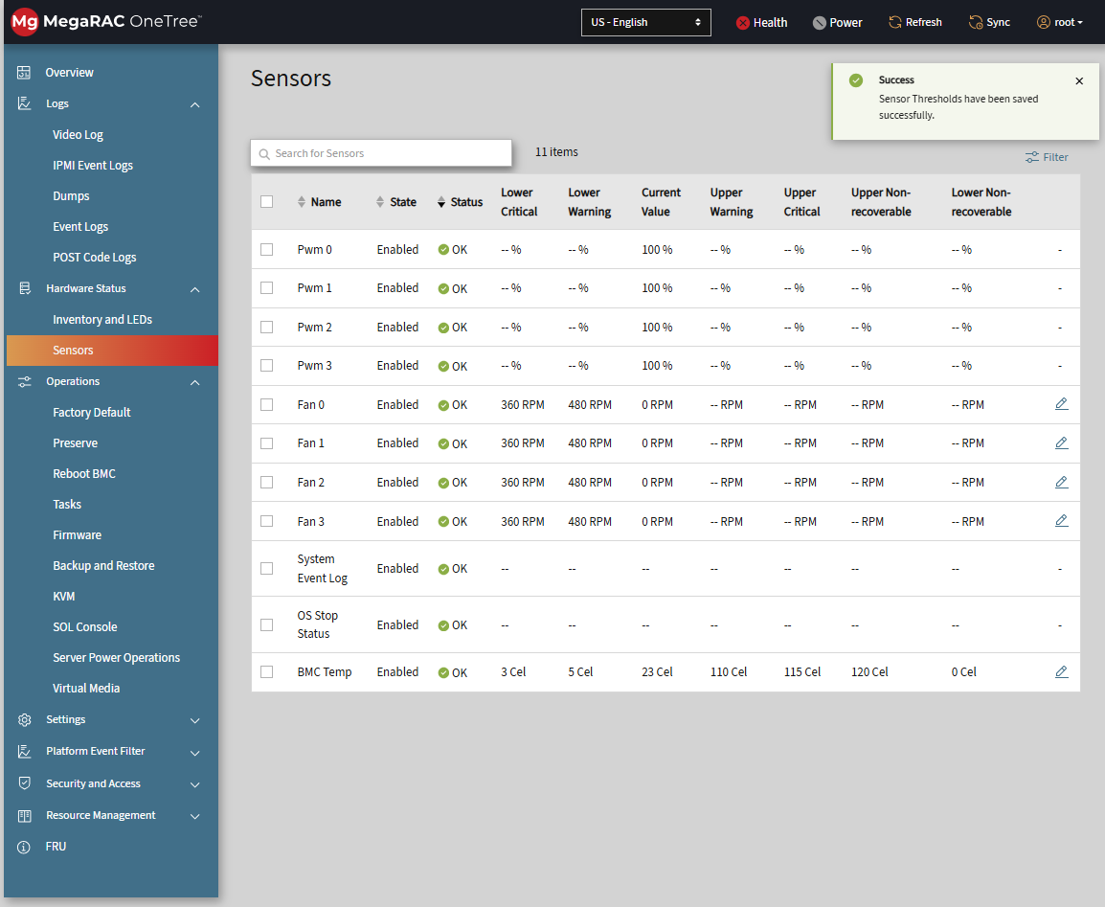

1.8 Advanced Log Settings
- Save Local Log settings.
- Save Remote Log settings.
- Validate both UDP and TCP configurations.

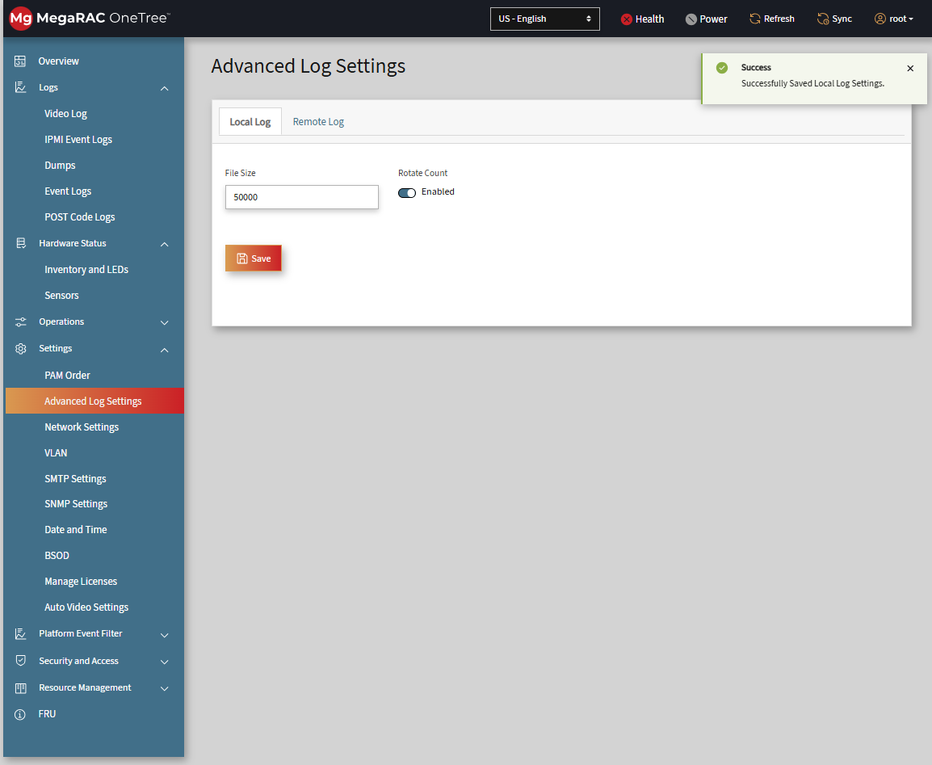
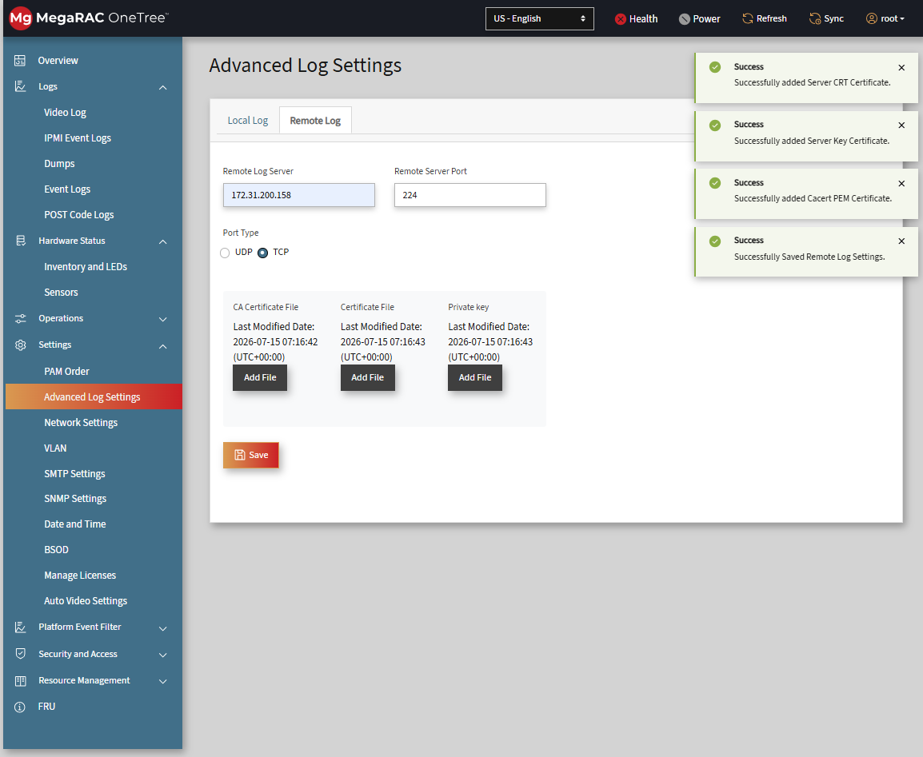

1.9 Network Settings
- Enable/disable IPv4 and IPv6 settings.
- Save configuration changes.
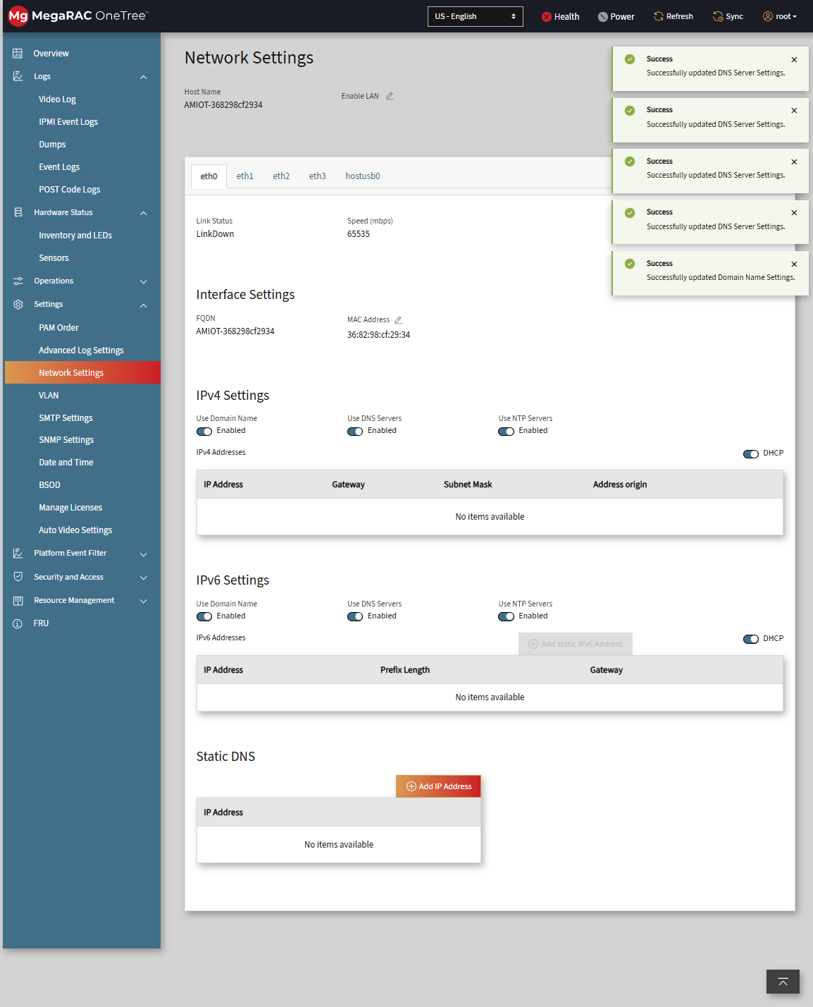

1.10 VLAN
- Create a VLAN and verify creation.
- Delete the created VLAN.
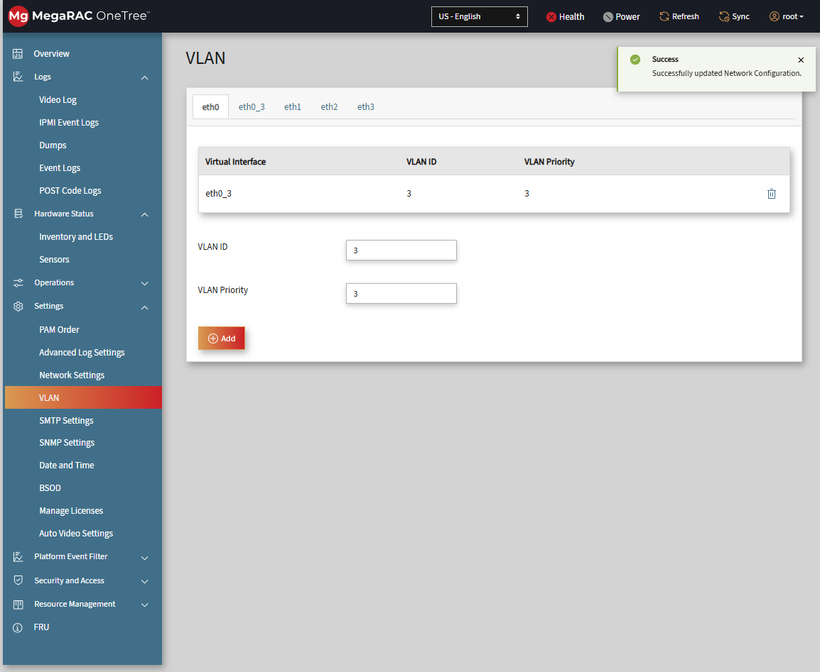

1.11 Date and Time
- Log in to webui
- go to settings and select Date and Time
- In the configure settings Click on NTP
- Change the time zone to Asia/Taipei
- SClick On Save
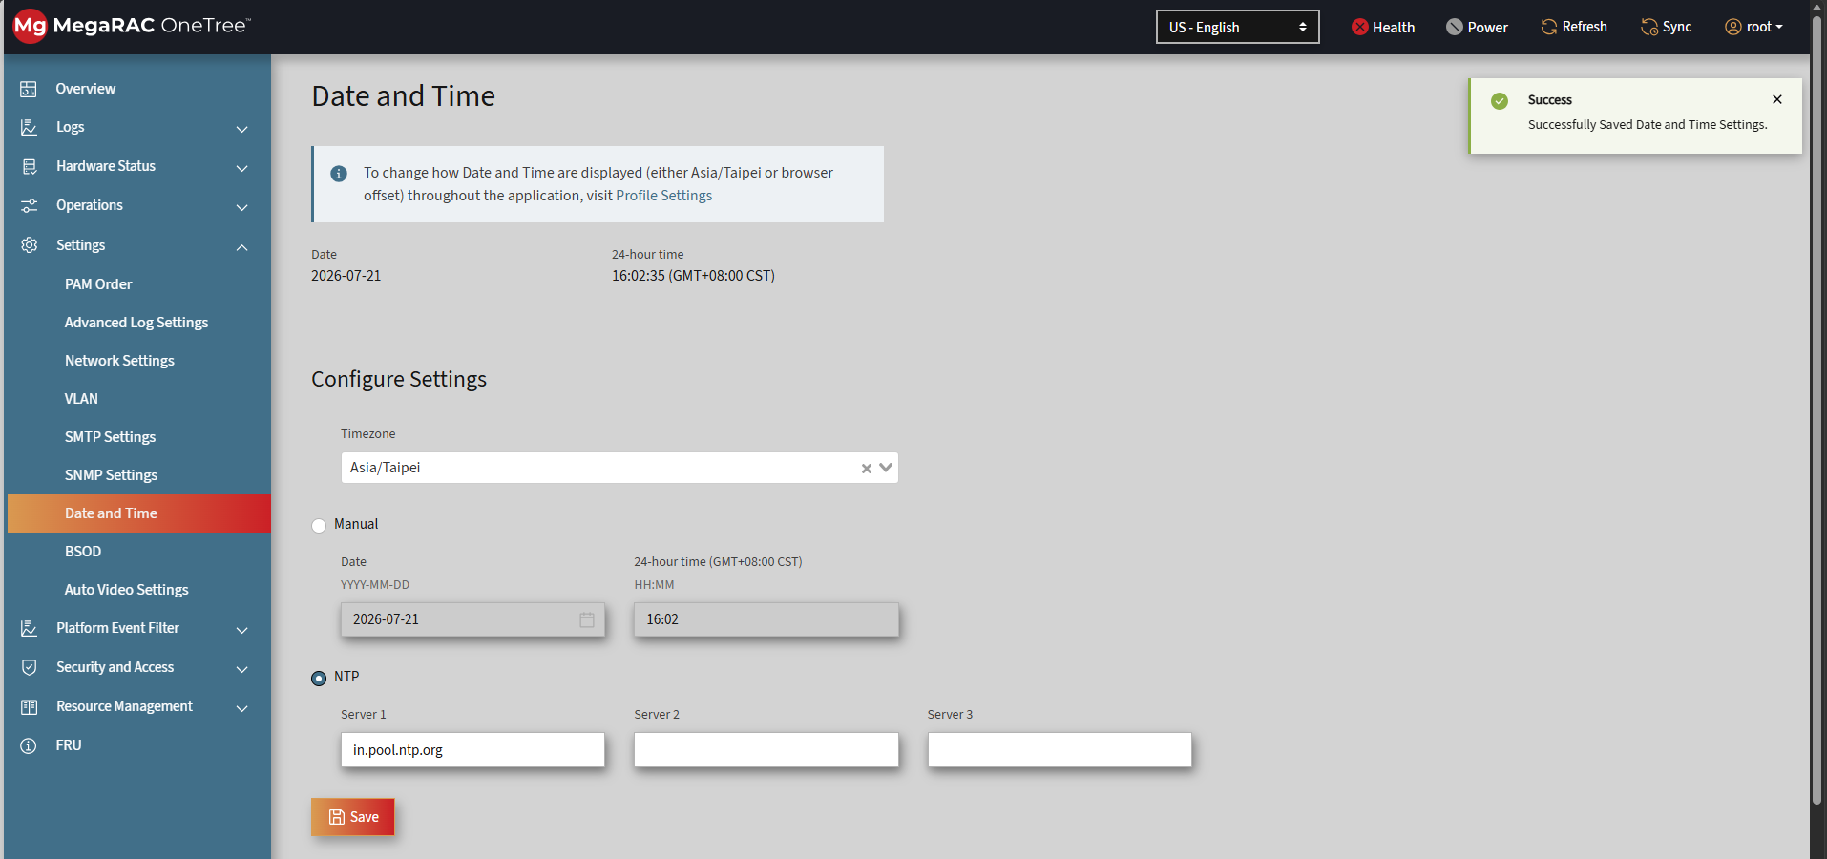

1.12 Event Filter
- Modify Event Actions. (Change Actions using )
- Update Event Retry Configuration.

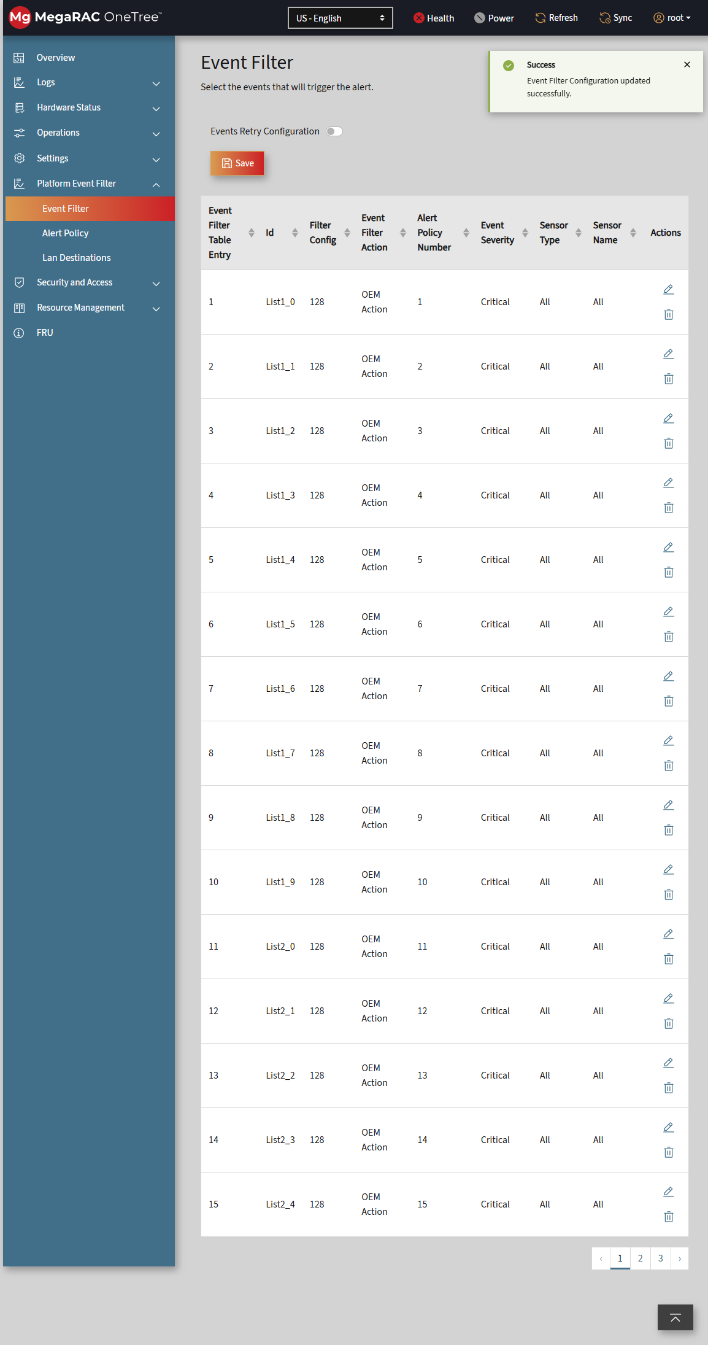

1.13 Alert Policy
- Update and save alert policies. (Try updating using )

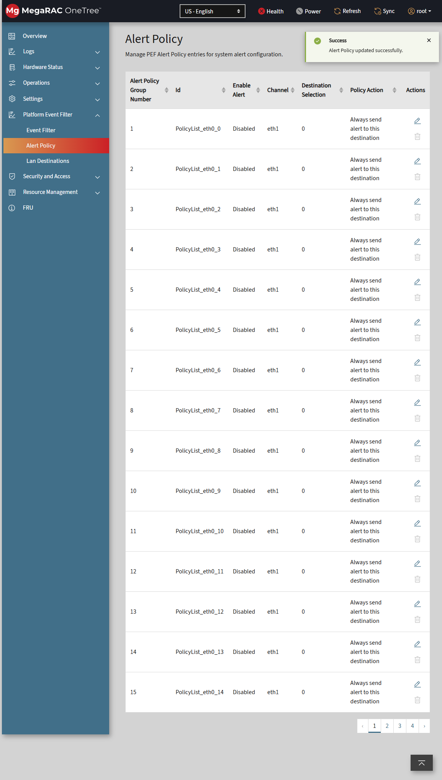

1.14 Lan Destinations
- Modify destination settings. (Update info using )
- Execute test notification. (Test using )

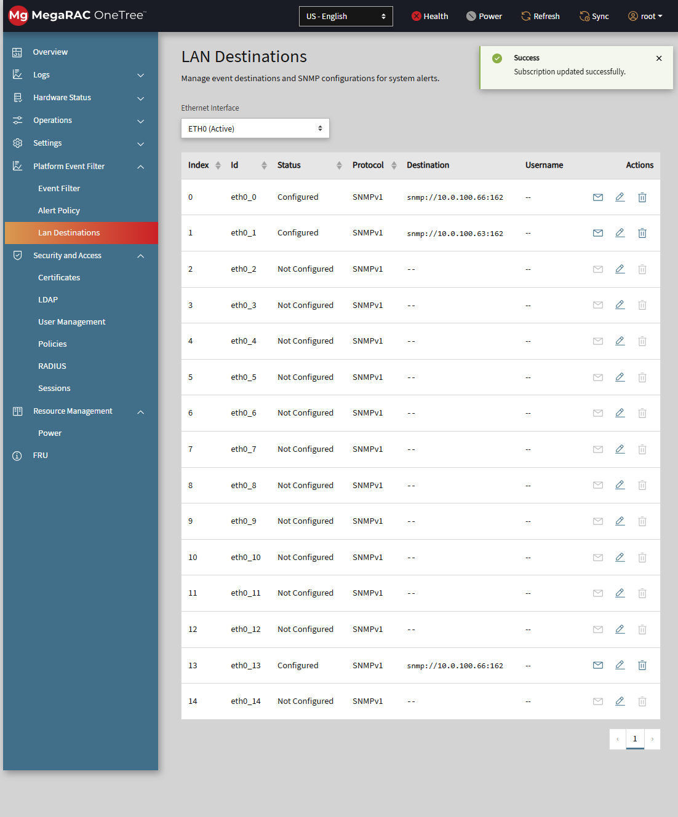

1.15 Certificates
- Upload and verify certificate installation.

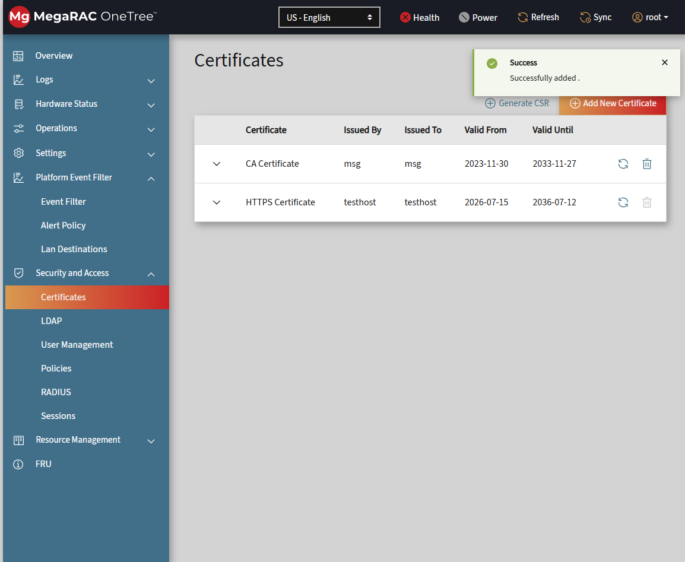

1.16 LDAP
- Configure LDAP.
- Login using LDAP user.

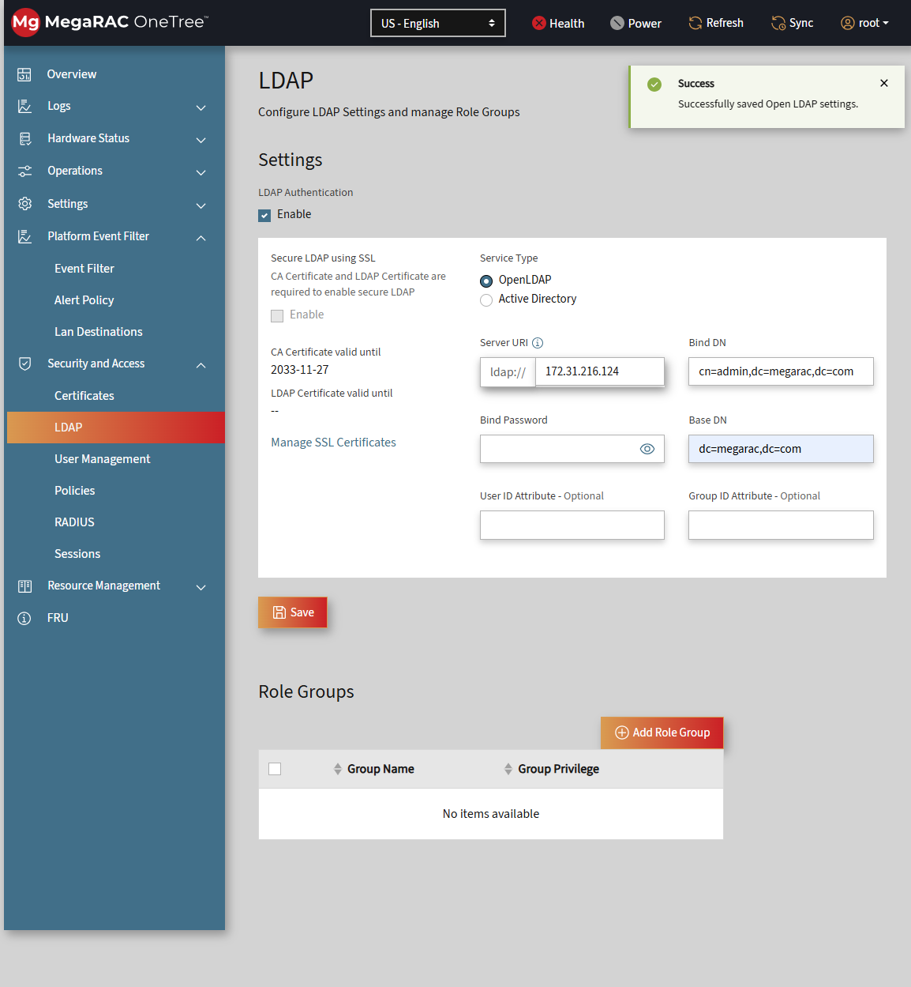

1.17 User management
- Create a user and verify login.

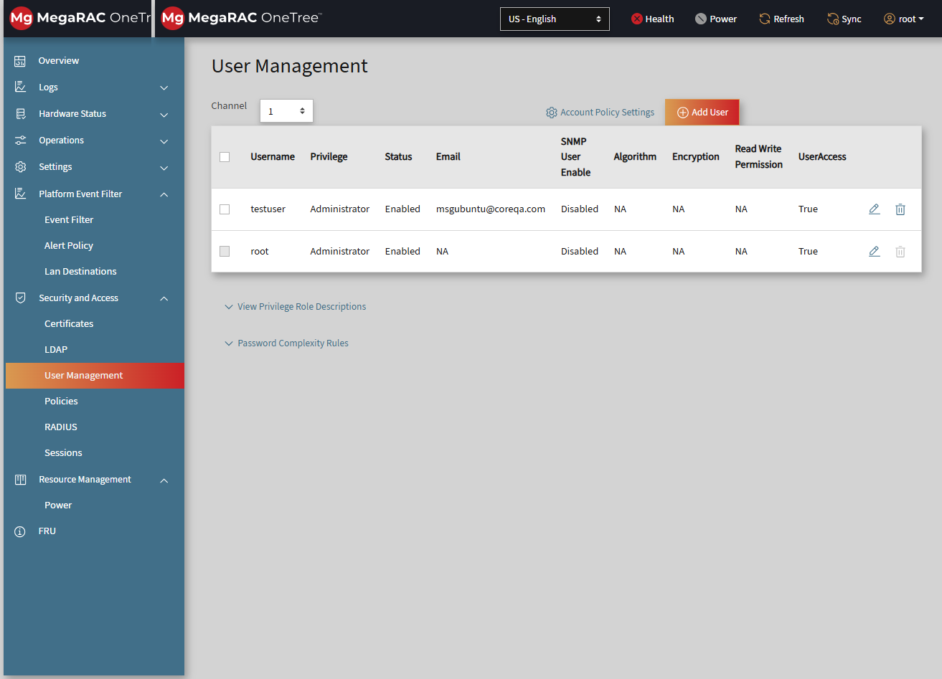

1.18 Sessions
- Open a web browser, access the BMC Web UI, and log in with valid credentials.
- Navigate to Security and Access from the main menu.
- Select Sessions to view all active sessions.
- Choose the desired web session and click Delete.
- Verify that the session is removed from the list and the corresponding Web UI session is terminated.

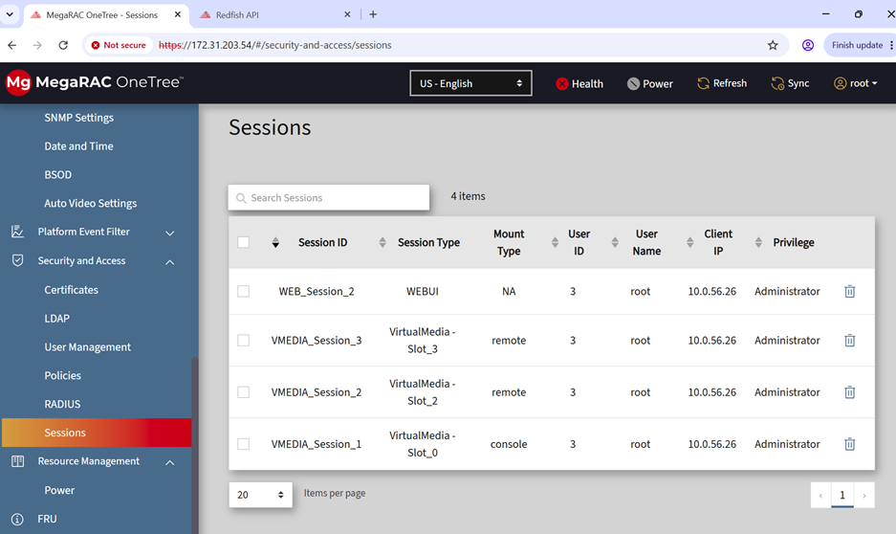

1.19 Policies
- Enable/disable policies.
- Modify SNMP settings.
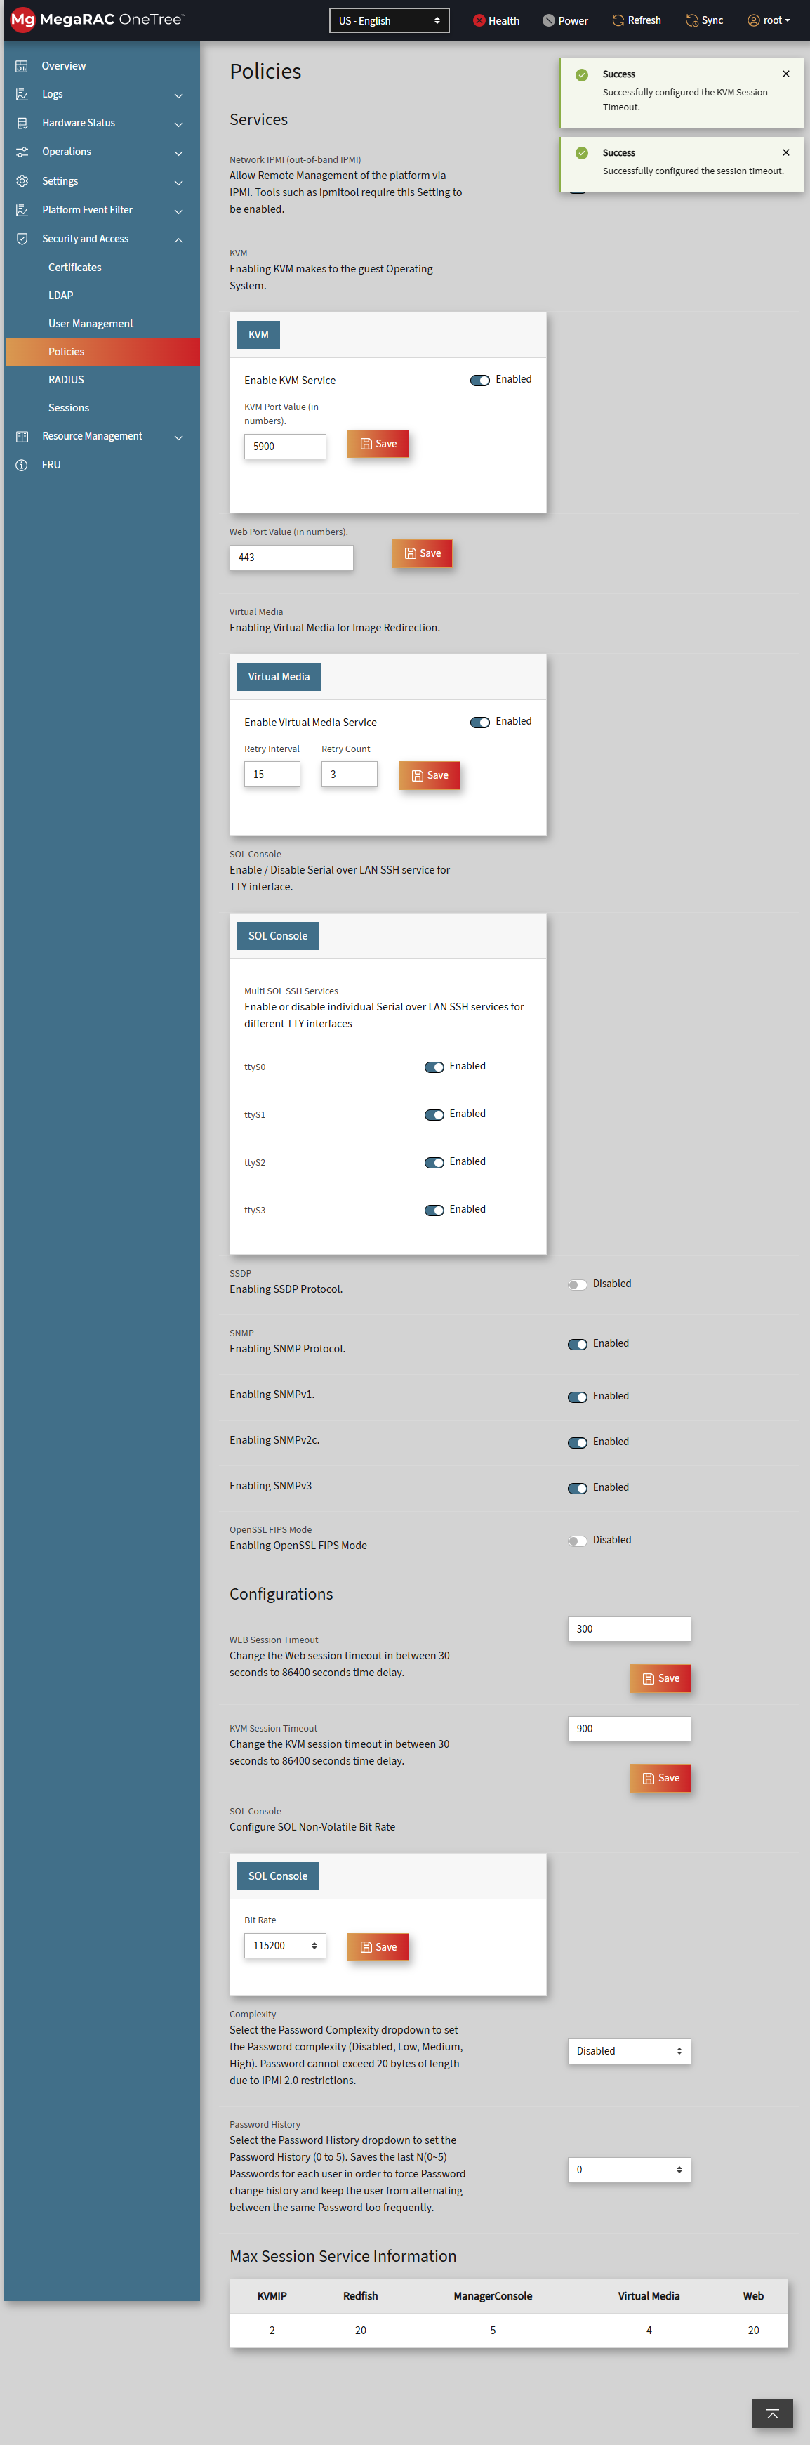

1.20 RADIUS
- Configure and save RADIUS settings.
- Verify login with Radius user.
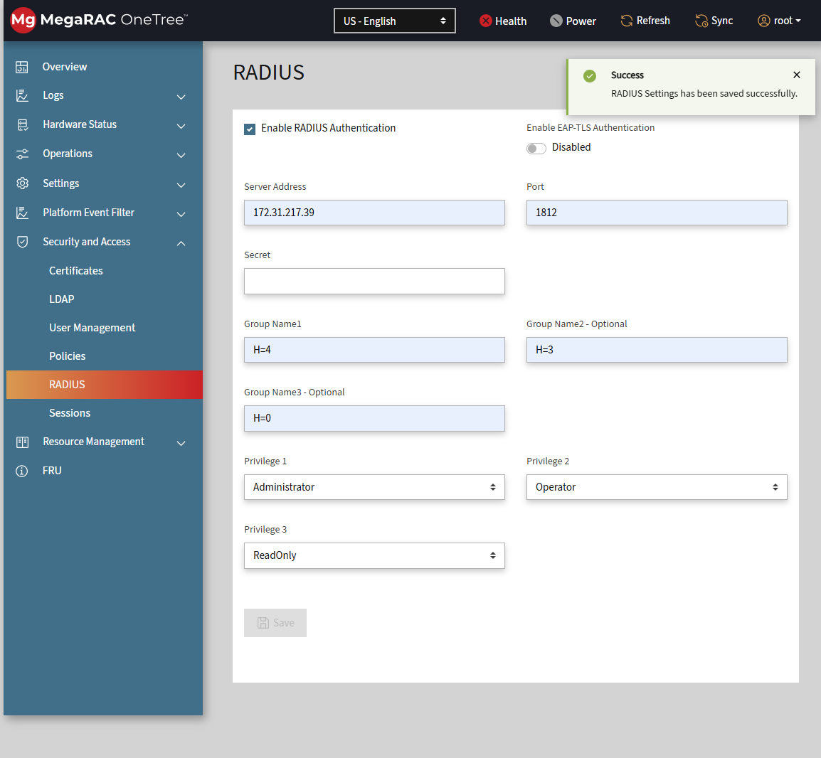

1.21 Preserve
- Enable preserve options and save.
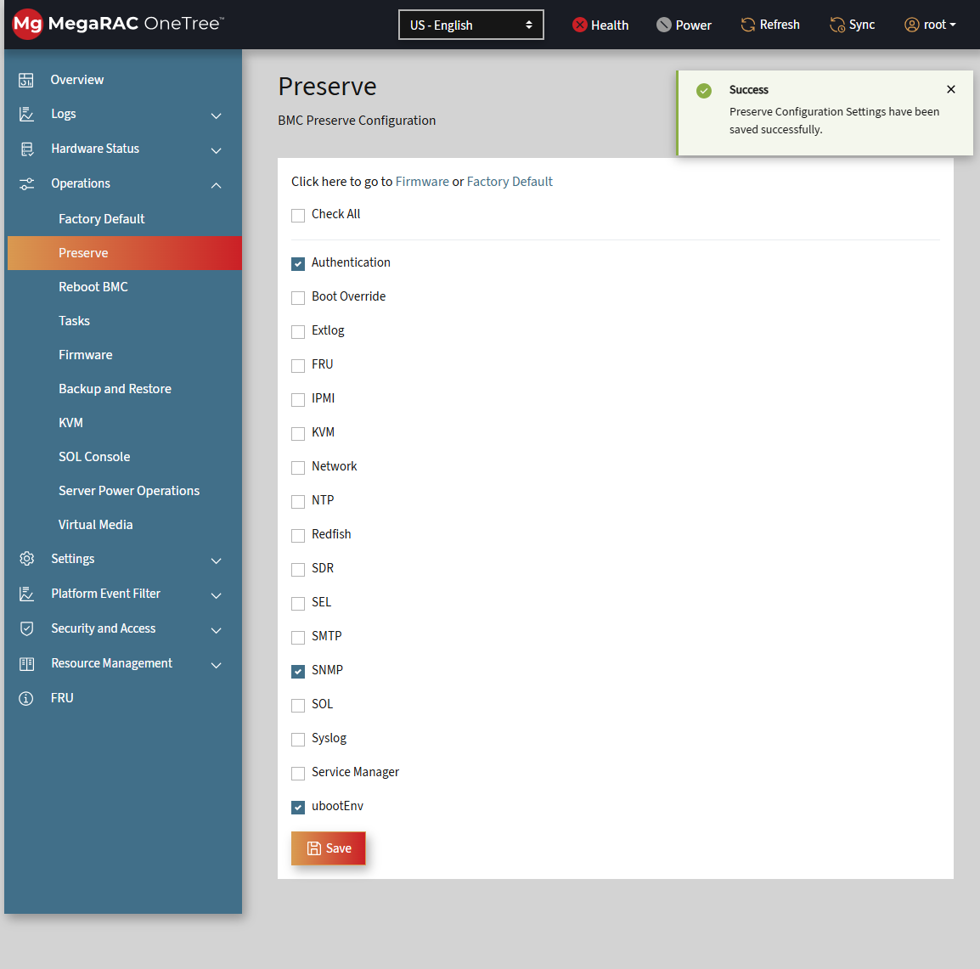

1.22 Tasks
- Verify background tasks are visible and completed.
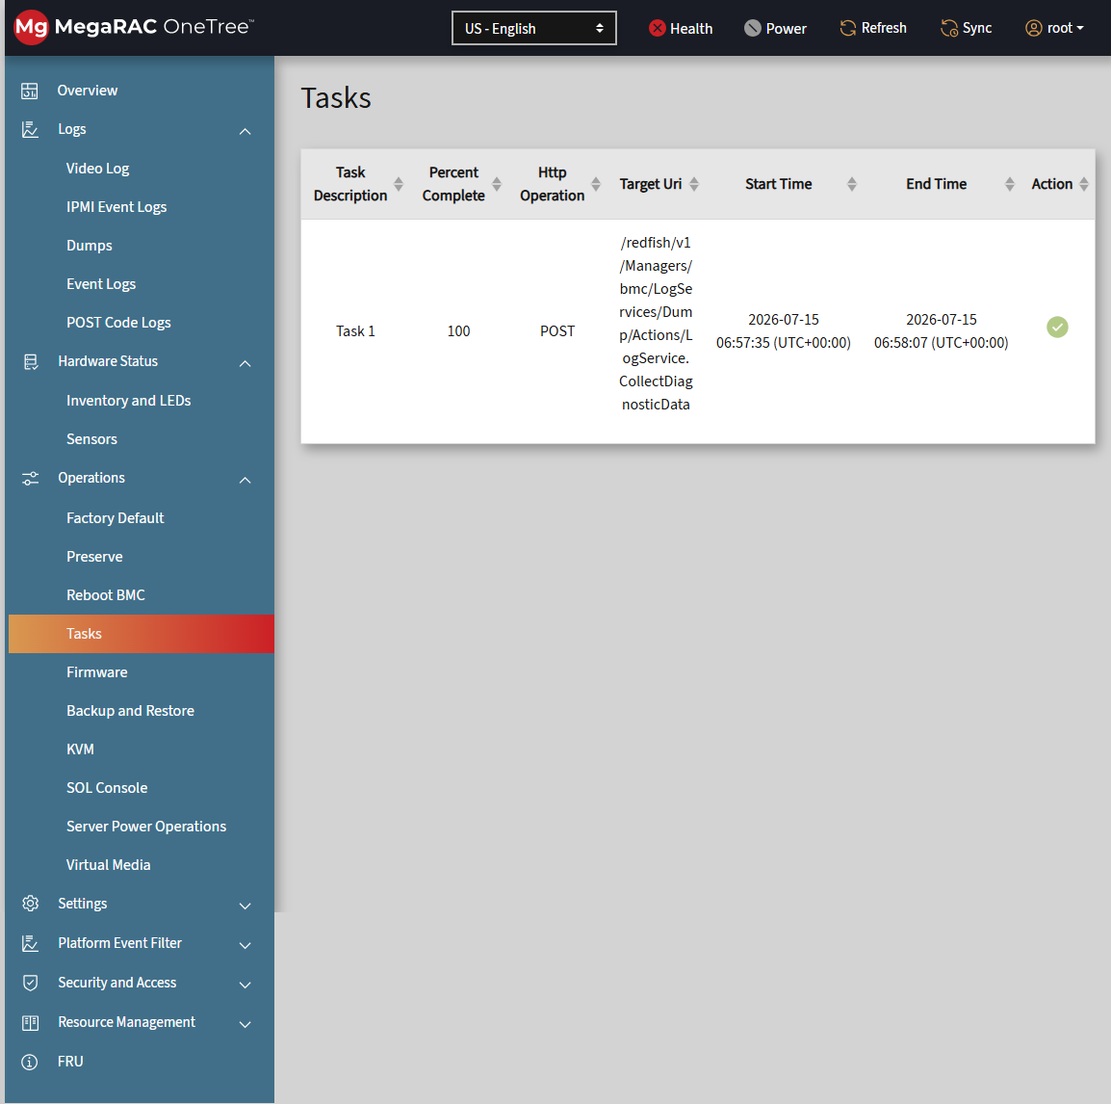

1.23 FRU
- Expand and verify FRU information.
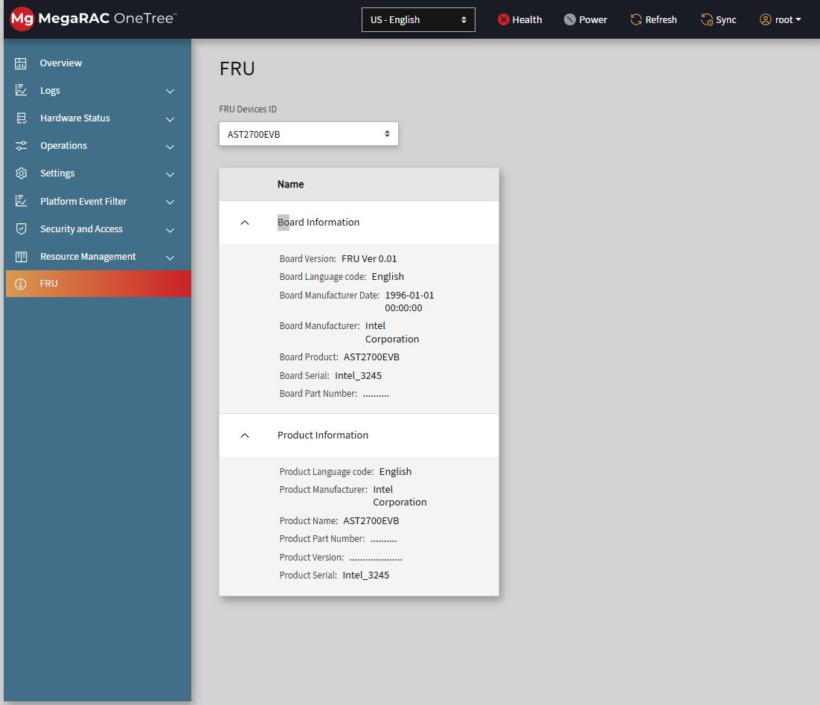

1.24 Power
- Modify and save power settings.
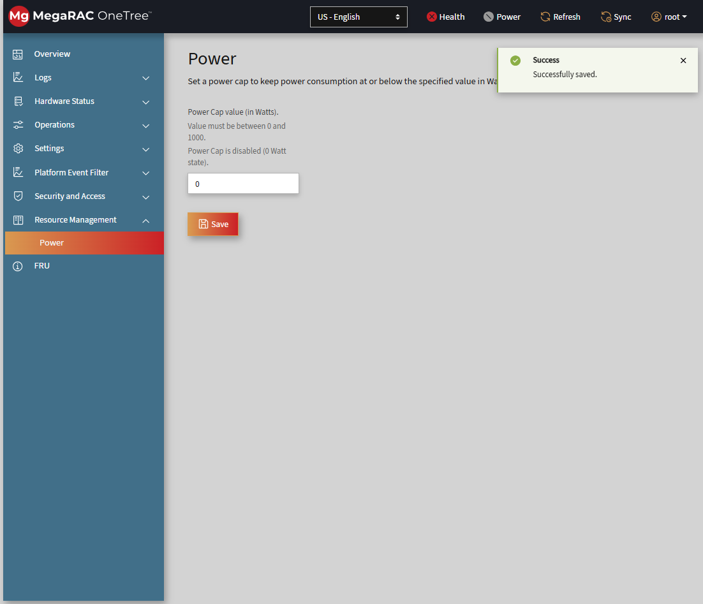

1.25 Reboot BMC
- Initiate BMC reboot and verify recovery.
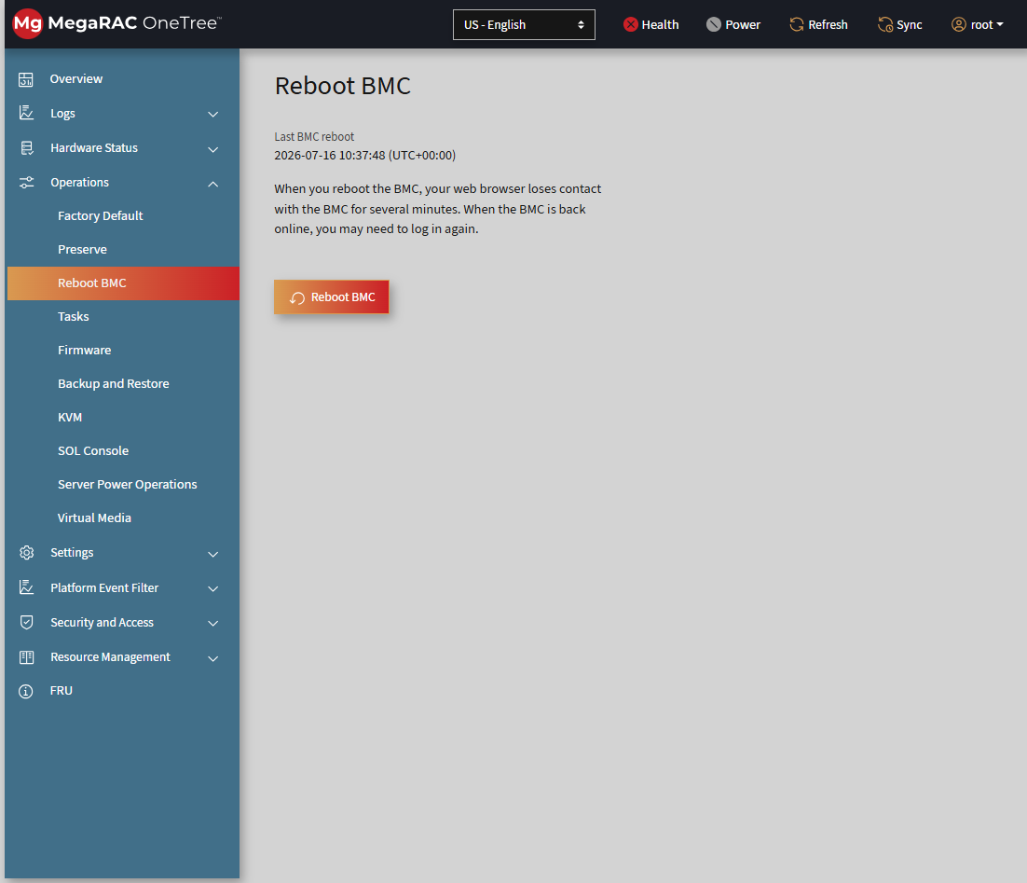

1.26 Factory Default
- Verify that preserve settings are reflected.
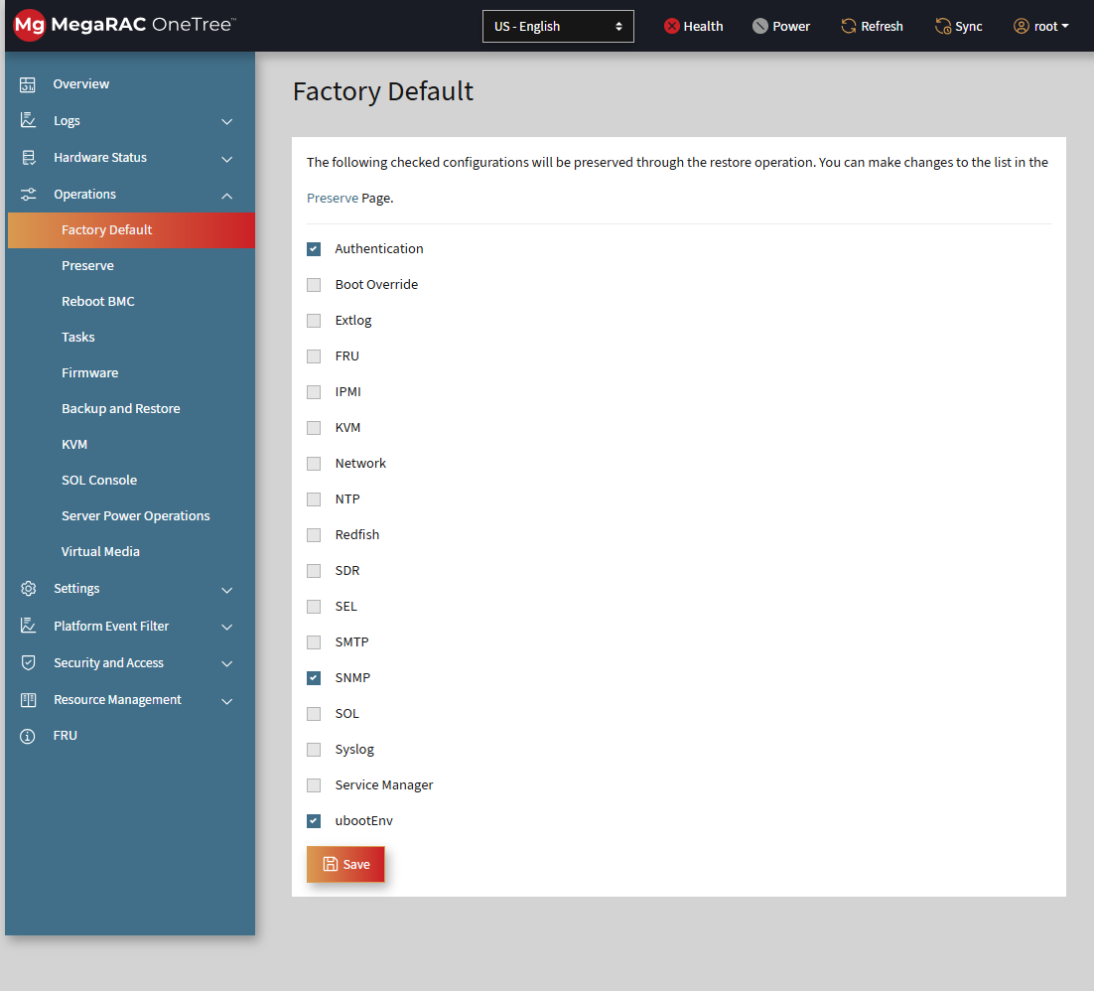

1.28 Virtual Media Redirection
Test Coverage: Virtual media redirection loaded from web browser and external servers using CIFS, HTTPS, and NFS.
Validate that virtual media redirection works correctly when media images are mounted from supported sources, and that the session management list displays all mounted media members.
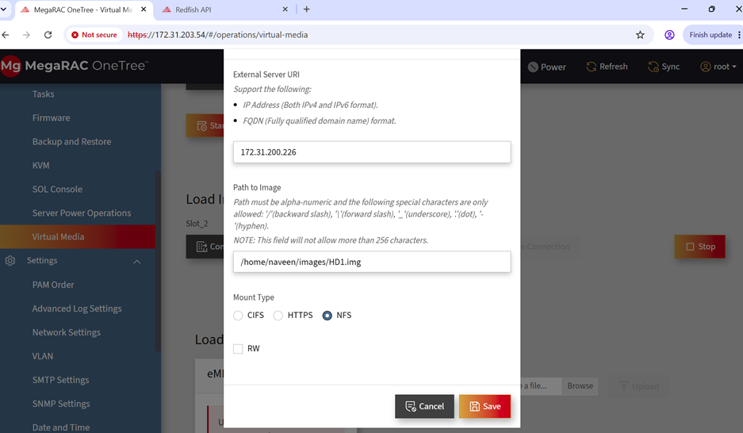
Test Scenarios
- Load virtual media from the web browser.
- Load virtual media from an external CIFS server.
- Load virtual media from an external HTTPS server.
- Load virtual media from an external NFS server.
- Verify that session management lists the complete media member list.
Expected Result
The session management page should display the full list of redirected media members for all supported source types, and each mounted image should remain accessible during the active session.
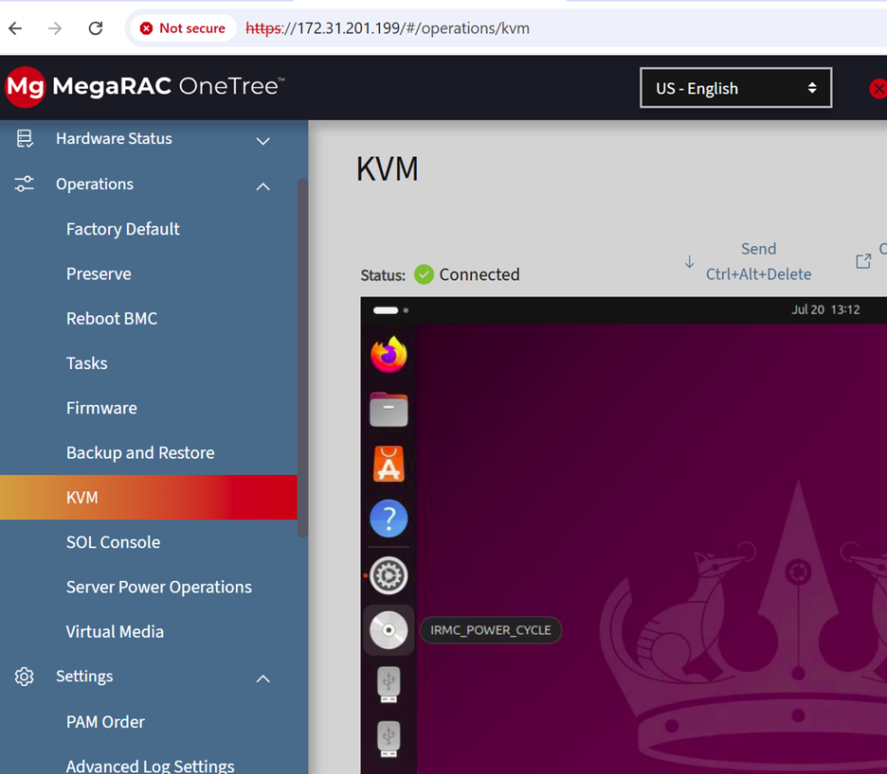


1.29 KVM
- Objective: Verify that the KVM console launches successfully and supports remote keyboard, video and mouse interaction.
- Precondition: The target system should be powered on and reachable through the management interface.
- Step 1: Log in to the management interface.
- Step 2: Navigate to the KVM or remote console option.
- Step 3: Launch the KVM console session.
- Step 4: Verify that the target system display is visible.
- Step 5: Perform keyboard and mouse actions from the remote console.
- Expected Result: The KVM session should open without errors, show the target system video output, and accept keyboard and mouse input correctly.
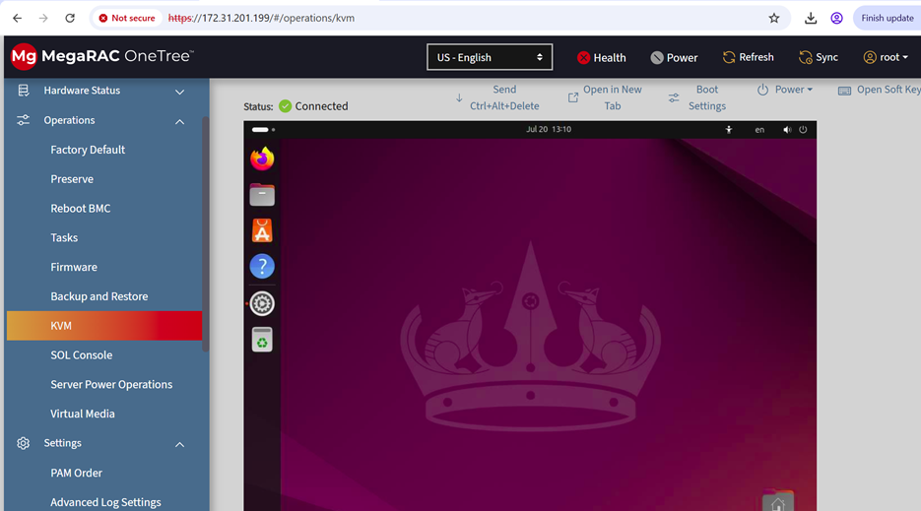
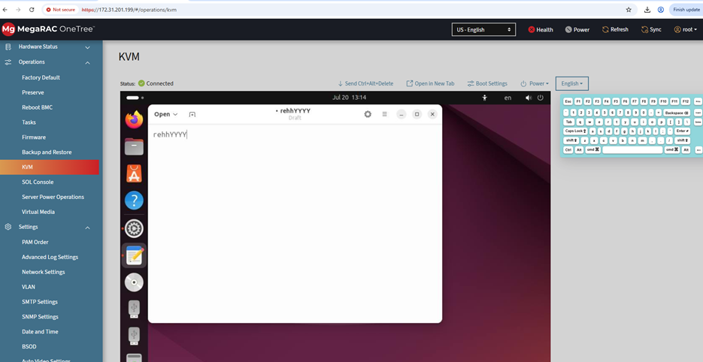

2 IPMI User Configuration & Privilege
IPMI USER CONFIGURATION and USER PRIVILEGE LEVEL
The Following Features are related to the creating the user using the ipmitool:
1. IPMI User Configuration
2. IPMI User Privilege Level
1. IPMI User Configuration
Step 1: Before creating the user checking the user list using the below ipmitool command
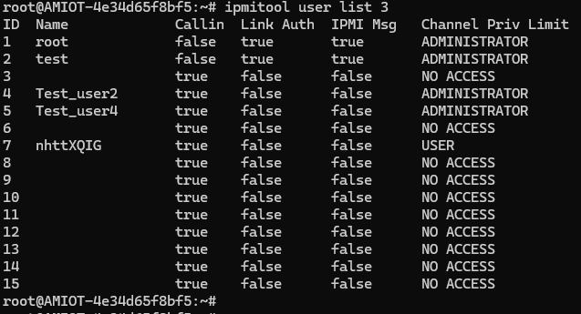
Step 2: Creating the new user with the Following ipmitool command
ipmitool user set name 11 test_user
Step 3: Setting the Password for newly created user with help of following ipmitool command
root@AMIOT-4e34d65f8bf5:~# ipmitool user set password 11 'OpenBmc@789'
Set User Password command successful (user 11)
root@AMIOT-4e34d65f8bf5:~#
Step 4: Enabling the newly created user with the help of following ipmitool command
ipmitool user enable 11
Step 5: Checking new user is created or not
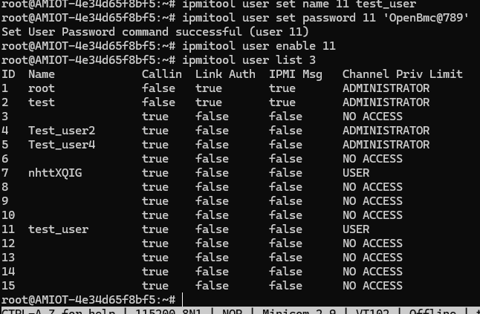
2. IPMI User Privilege Level
Step 1: Required to follow the above steps create the user and need to check current setting
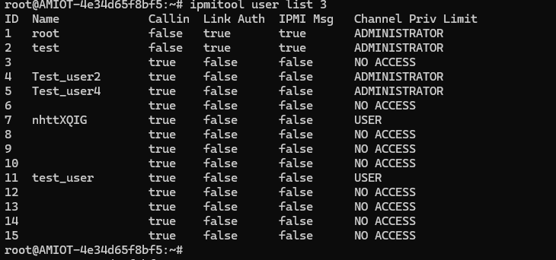
Step 2: Need Enable the privilege using the Following command and need to test it is properly set or not
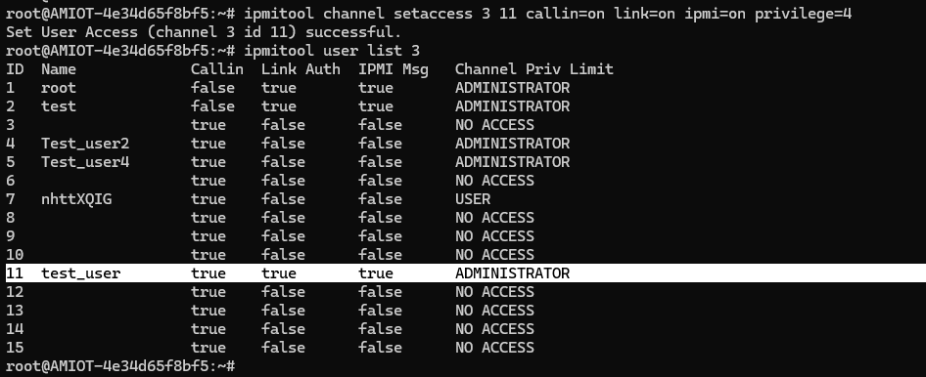

3 Sensor
Step 1: Get Sensor reading
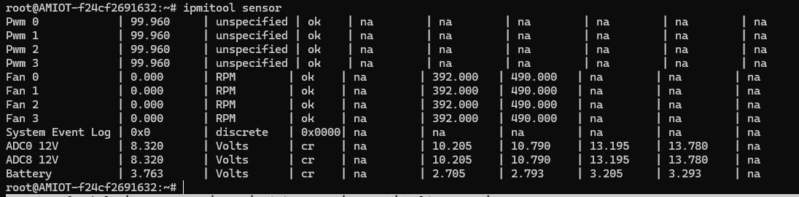
Step 2: Get Sensor Type
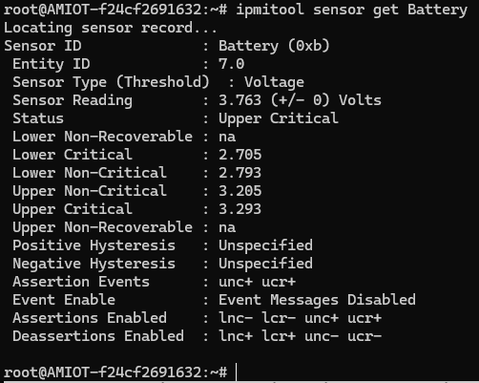
Step 3: Get Sensor event enable
1. Get the sdr list
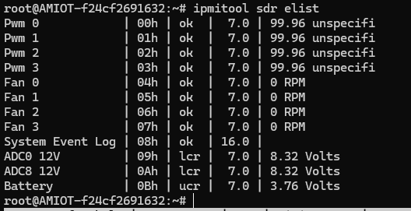
2. Check get sensor event enable on sensor
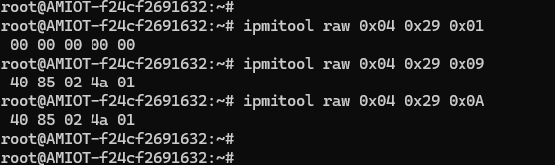
Step 4: Get/Set Sensor threshold
- Get “Battery“sensor number
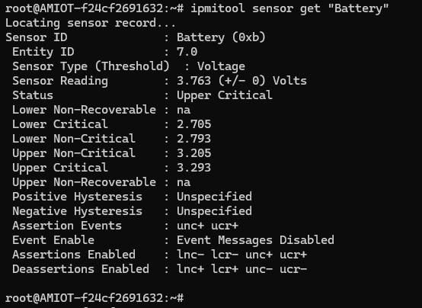
- Get Sensor Threshold via IPMI
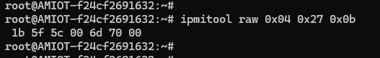
- Set Sensor Threshold via IPMI
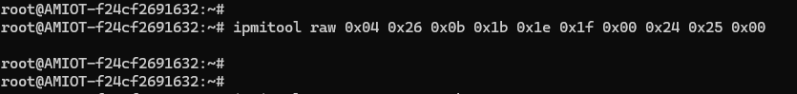
- Check Sensor Thresholds are updated or not
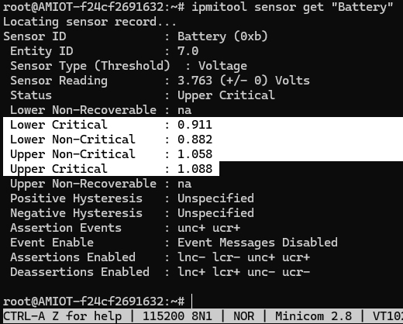

4 PEF & SMTP
- PEF
Step 1: We need to create a new user after the successful completion of the login with root user credentials. After creation of new user, we need to login with the new user credentials.
1. Login with the root credentials
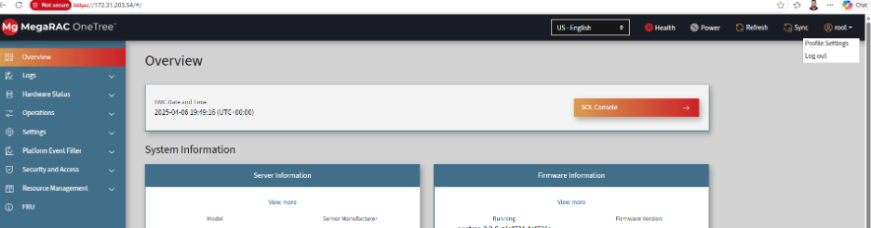
2. Need to create the new user with the Following options
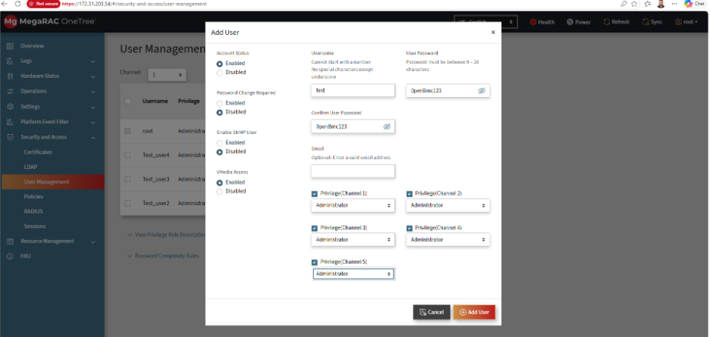
3. After creating the New User Need to Logout with the Existing user and need login with the new credentials
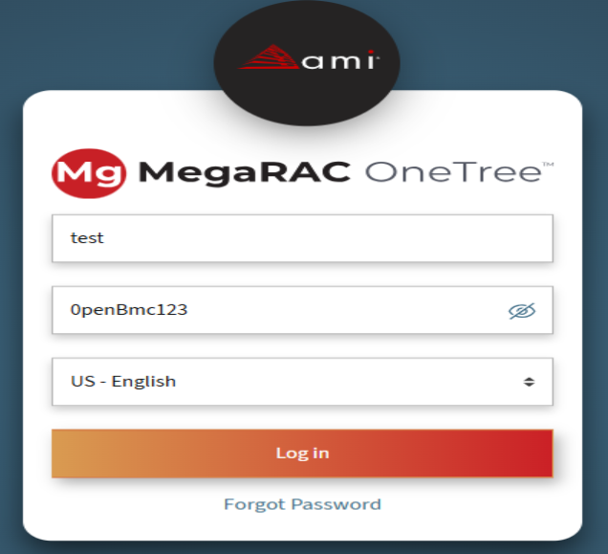
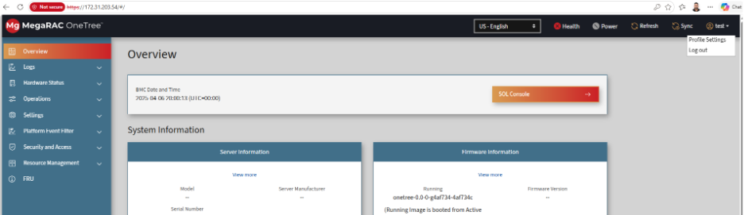
Step 2: Configure the SMTP settings as per the Provided Server information
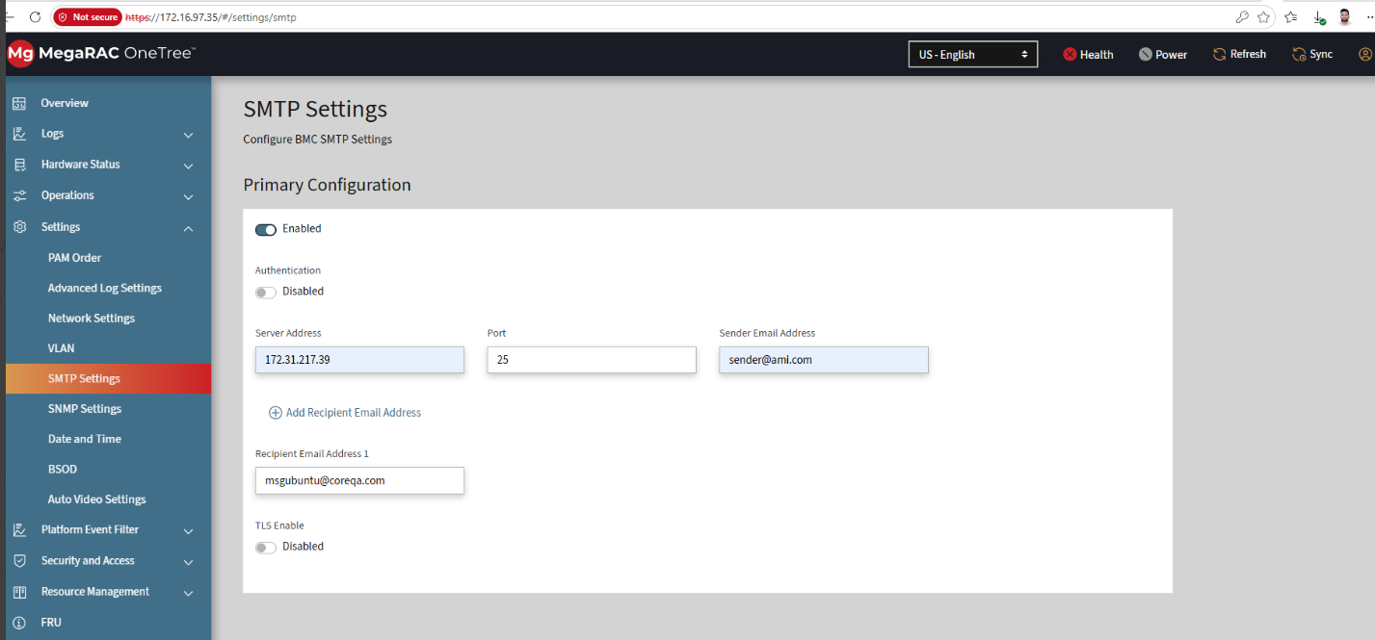
Step 3: Configure the SNMP with the following options with Read write option
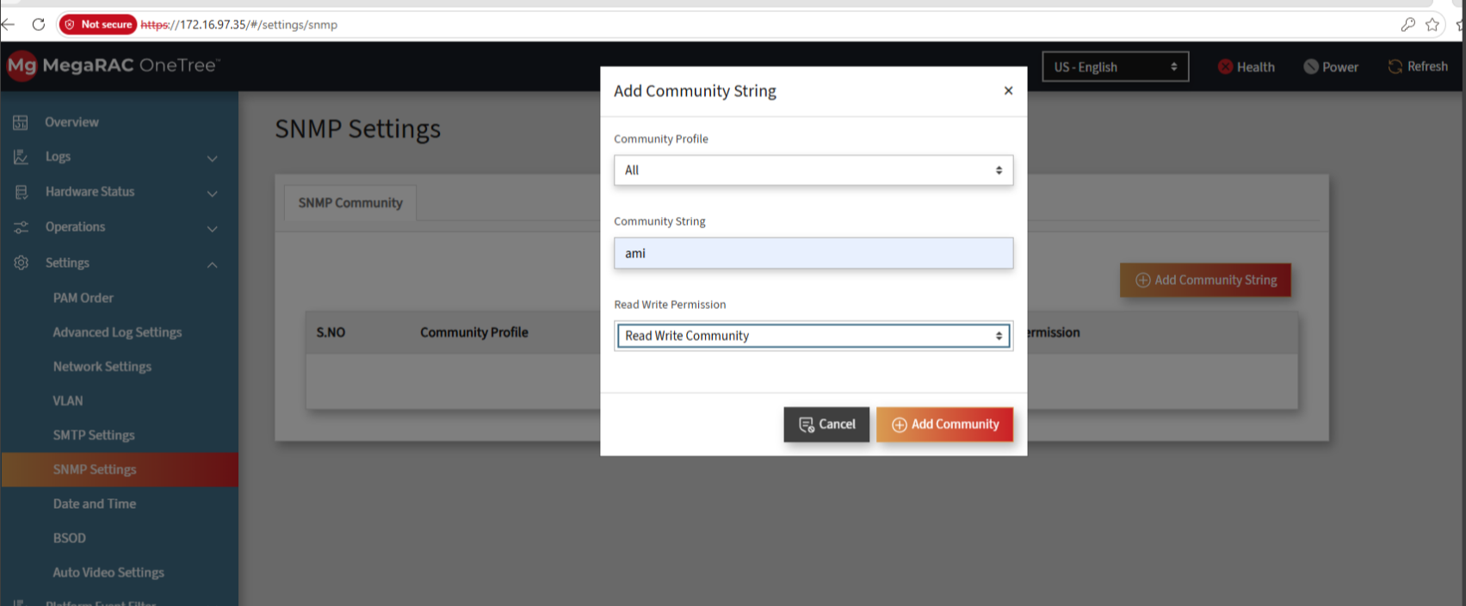
Step 4: In PEF Alert Policy we need to update with Particular ethernet interface as below
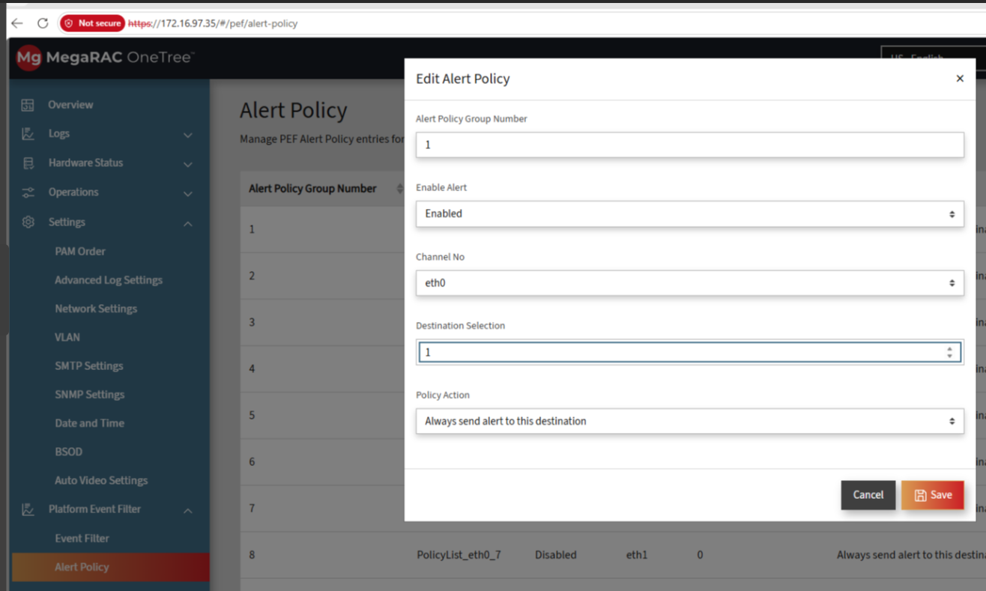
Step 5: In PEF Lan destinations we need to update the below details with one VM IP address
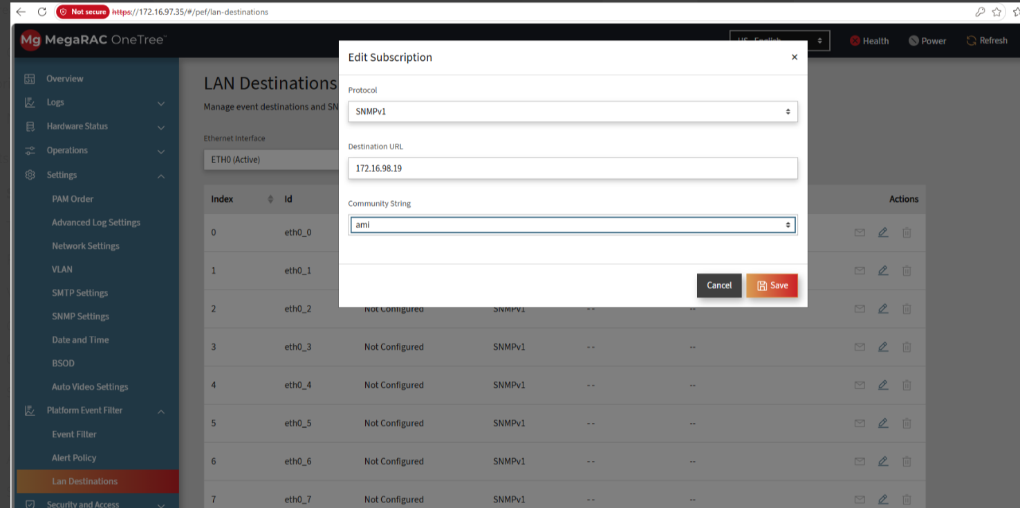
Step 6: After the Configurations We need run the tcpdump in the VM like below
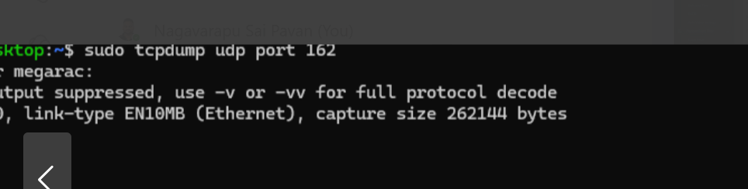
Step 7: From the BMC minicom console We need to send the Any Event (1 -> Temp sensor)
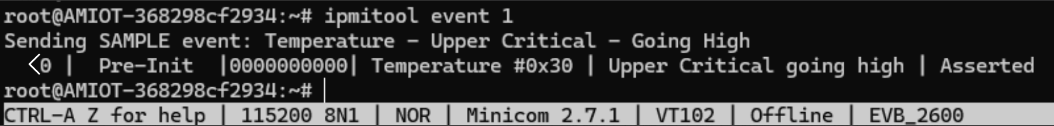
Step 8: After Sending the Event We will get the Update in the tcpdemp,because it is in listen mode
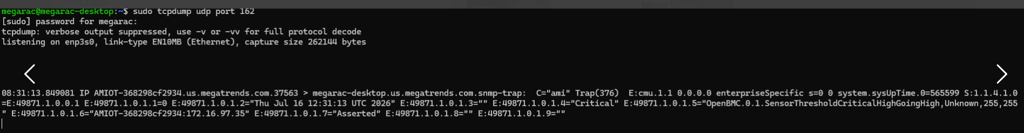
SMTP
Step 1: As mentioned in the PEF need to create the user and login with the new credentials
Step 2: Configure the SMTP settings as per the Provided Server information
Step 3: Configure the SNMP with the following options with Read write option
Step 4: In PEF need to modify the Alert manger as mentioned below
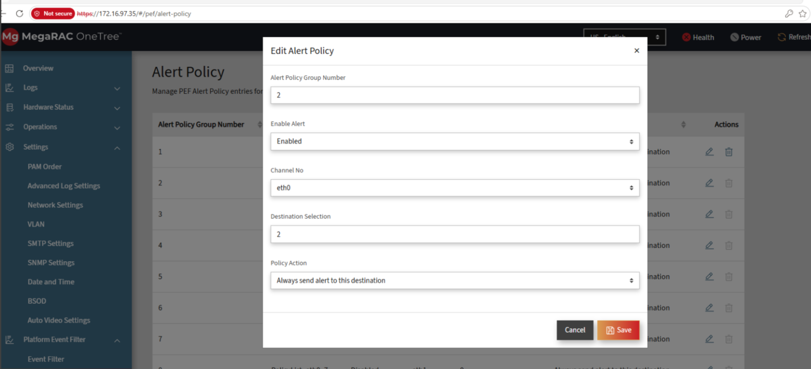
Step 5: In User Setting we need to update the mail id
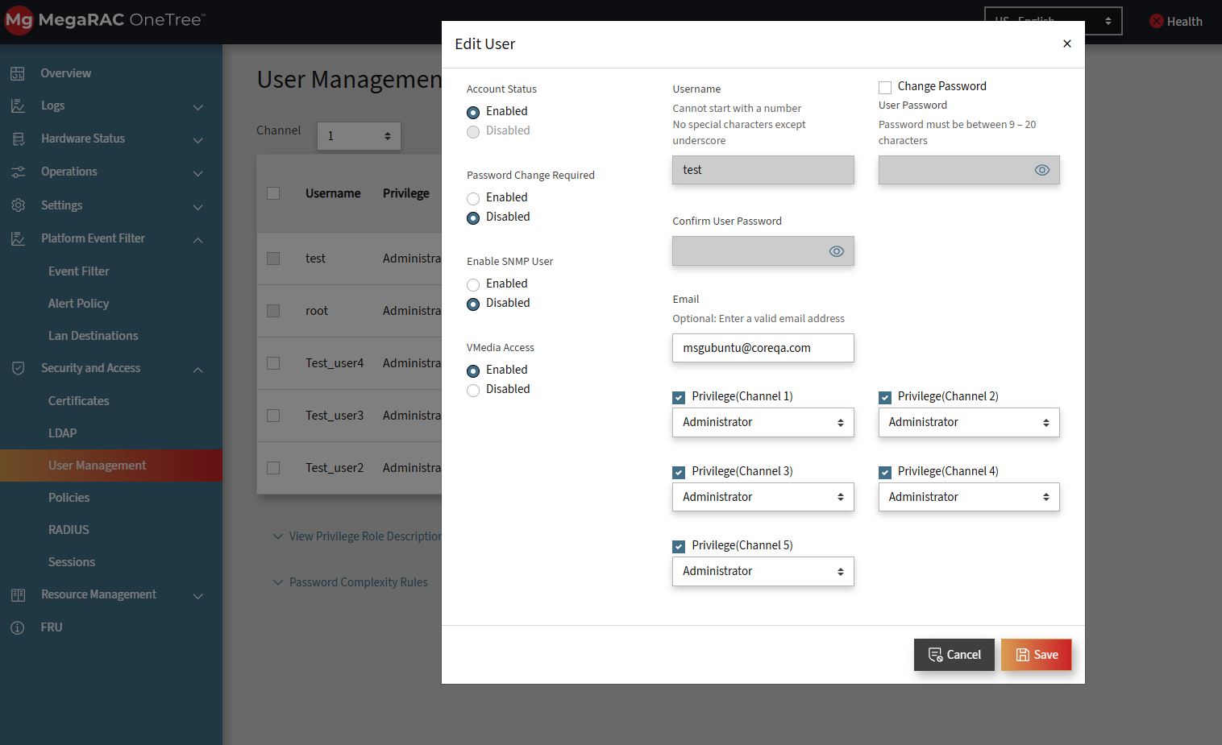
Step 6: In PEF need to modify the Lan destinations as mentioned below
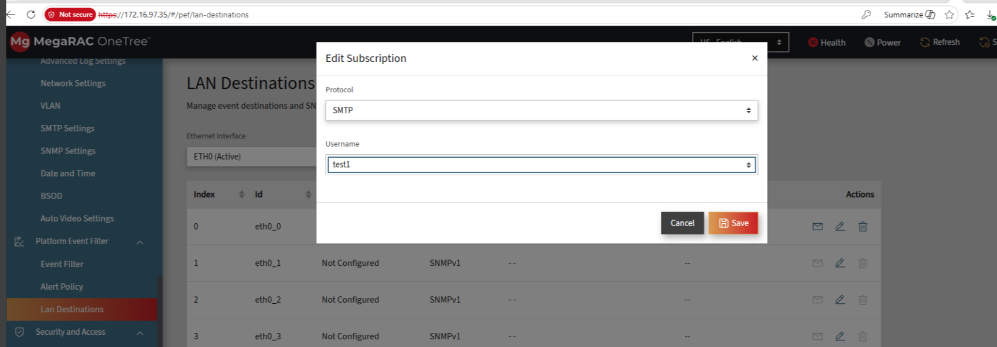
Step 7: After the Configurations We need run the tcpdump in the VM like below

Step 8: From the BMC minicom console We need to send the Any Event (2 -> Voltage)
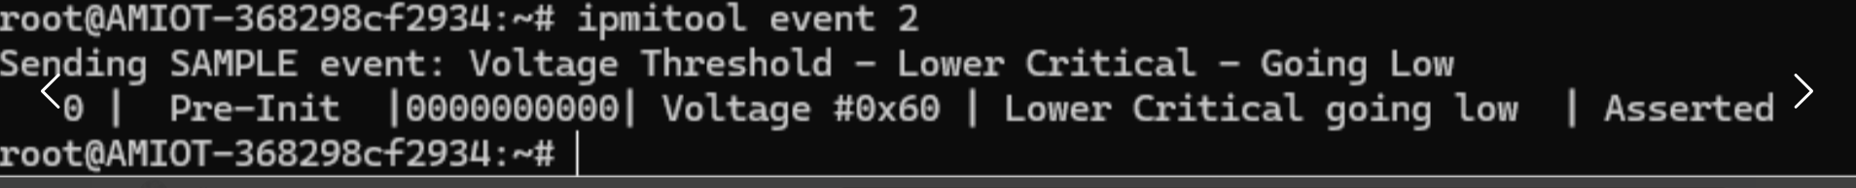
Step 9: After Sending the Event We will get the Update in the tcpdemp,because it is in listen mode
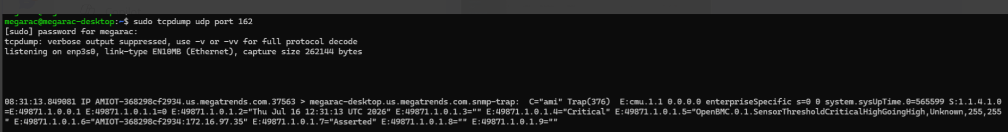
Step 10: Take the ssh into the SMTP host and check the new folder any smtp file is created or not like below
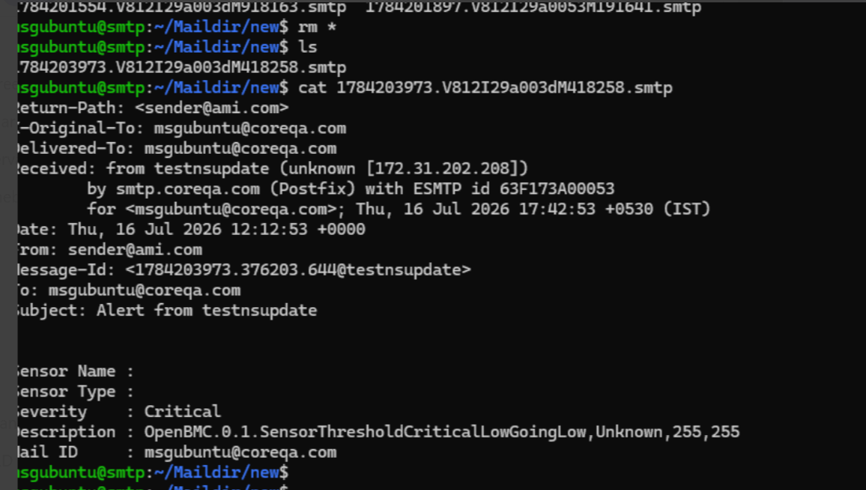

5 Watchdog & FRU
Watchdog:
Step 1: Get Watchdog TIme
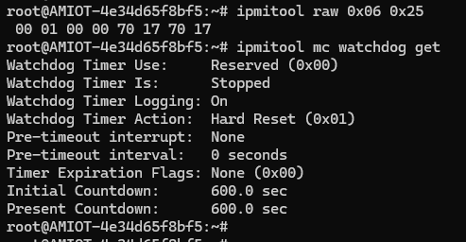
Step 2: set Watchdog Time
root@AMIOT-4e34d65f8bf5:~# ipmitool raw 0x06 0x24 0x01 0x03 0x00 0x00 0x64 0x00
root@AMIOT-4e34d65f8bf5:~#
Note: Again, Checked Able to set or not
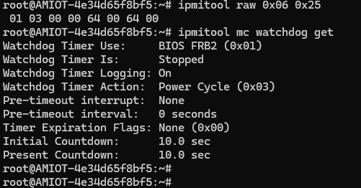
Step 3: Reset Watchdog Timer
root@AMIOT-4e34d65f8bf5:~# ipmitool raw 0x06 0x22
root@AMIOT-4e34d65f8bf5:~#
Note: Again, Checked Able to reset or not
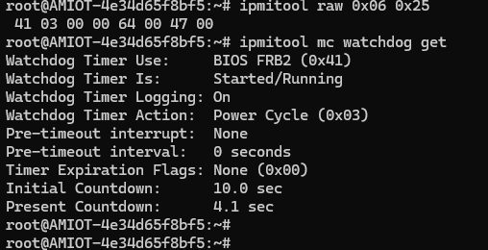
Step 4: Hardware Watchdog
1. Verified systemd watchdog configuration:
- Checked /etc/systemd/system.conf for RuntimeWatchdogSec and WatchdogDevice.
- Confirmed settings were commented out and systemd was running with its default watchdog configuration.
2. Verified watchdog device and driver:
- Confirmed presence of /dev/watchdog0.
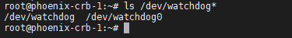
- Checked kernel logs and verified: dmesg | grep -i watchdog | head -n 10
- Verified watchdog identity and sysfs attributes under: /sys/class/watchdog/watchdog0/
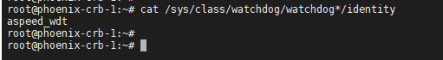
3. Verified watchdog hardware status:
- Read AST2600 watchdog-related registers using devmem.
1. devmem 0x1e78502c 32
2. devmem 0x1E620064 32
- Confirmed watchdog hardware was accessible and reporting valid register values.
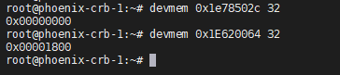
4. Disabled systemd watchdog petting:
- Created: /etc/systemd/system.conf.d/watchdog-test.conf
with:
  - [Manager]
RuntimeWatchdogSec=0
- Re-executed systemd using: systemctl daemon-reexec
5. Triggered watchdog timeout:
- Armed the hardware watchdog using:
echo 1 > /dev/watchdog0
- Left the system idle without further interaction.
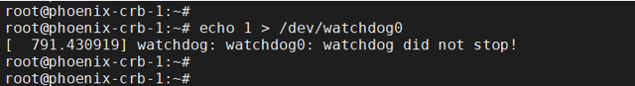
6. Verified watchdog recovery:
- BMC rebooted autonomously after approximately 2 minutes due to watchdog expiration.
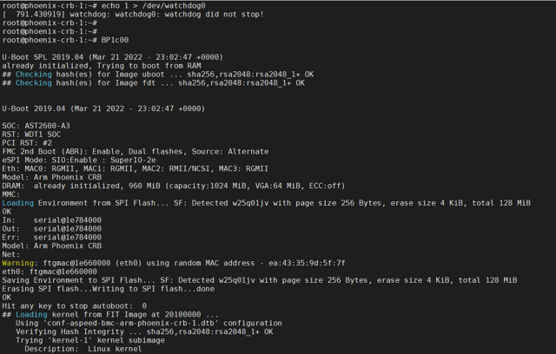
- Verified aspeed_wdt driver re-initialization from dmesg logs.
- Checked: /sys/class/watchdog/watchdog0/bootstatus
to confirm watchdog reset indication. A non-zero value typically indicates a watchdog-triggered reset.
7. Restored the original system configuration:
  - Removed watchdog test configuration.
  - Re-executed systemd to restore normal watchdog behavior.
    - rm /etc/systemd/system.conf.d/watchdog-test.conf
    - systemctl daemon-reexec
FRU
Step 1: Read FRU using the ipmitool command ipmitool fru print 0
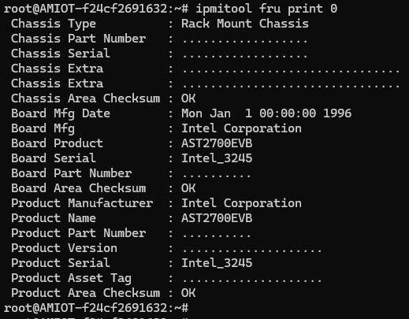
Step 2: Write FRU
1. Write FRU using the ipmitool command ipmitool fru edit 0 field b 0 "test"
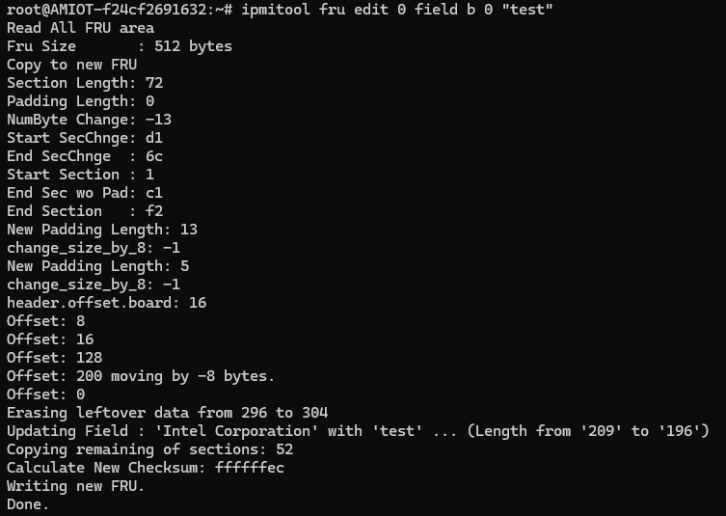2. Read FRU after write to check able to write or not
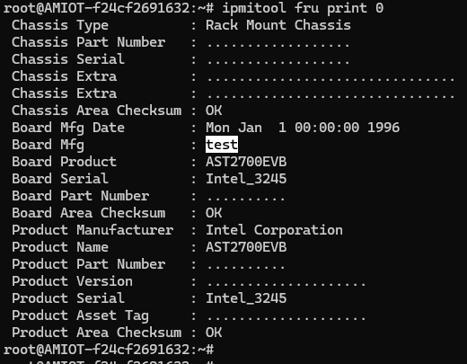
Step 3: Get FRU inventory Area Info
1. Check the FRU list using the ipmitool command ipmitool fru list
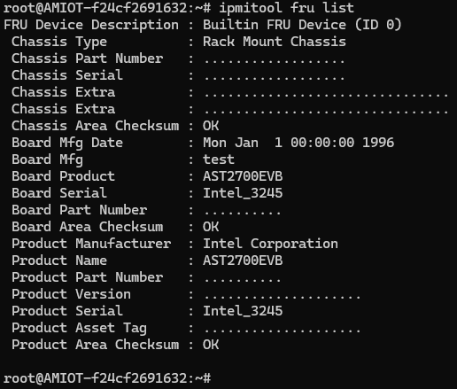
2. Get FRU inventory area info using the ipmi command ipmitool raw 0x0A 0x10 0x00
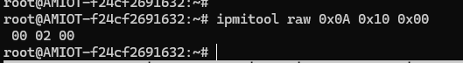

6 User Management
Local
To check the Local Feature Functionality, we need to create a new user after the successful completion of the login with root user credentials. After creation of new user, we need to login with the new user credentials.
Step 1: Login with the root credentials
Step 2: Need to create the new user with the Following options
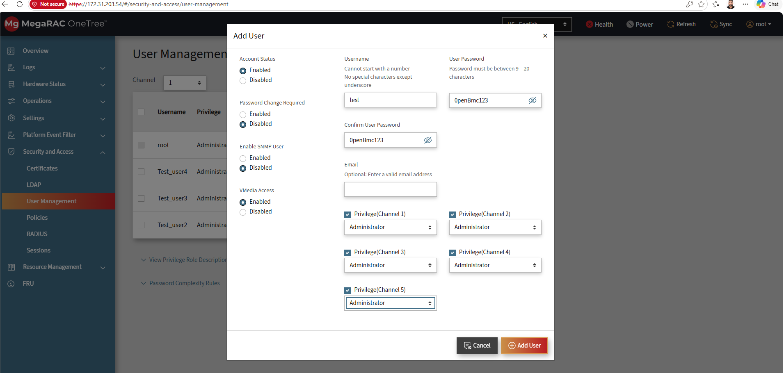
Step 3: After creating the New User Need to Logout with the Existing user and need login with the new credentials
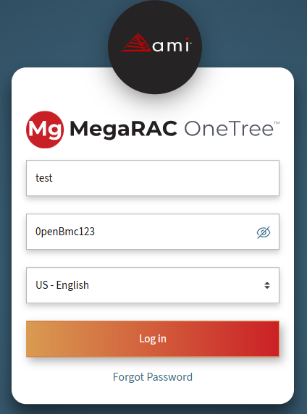
Note: Try to login with new credentials two or more times.
OpenLDAP
Step 1: Need to create the New User As mentioned in the Local Feature and need to login with the new credentials.
Step 2: We Need fill the Above Server Details in the LDAP option (By Default it is 0penLDAP) and need to Save the Details.
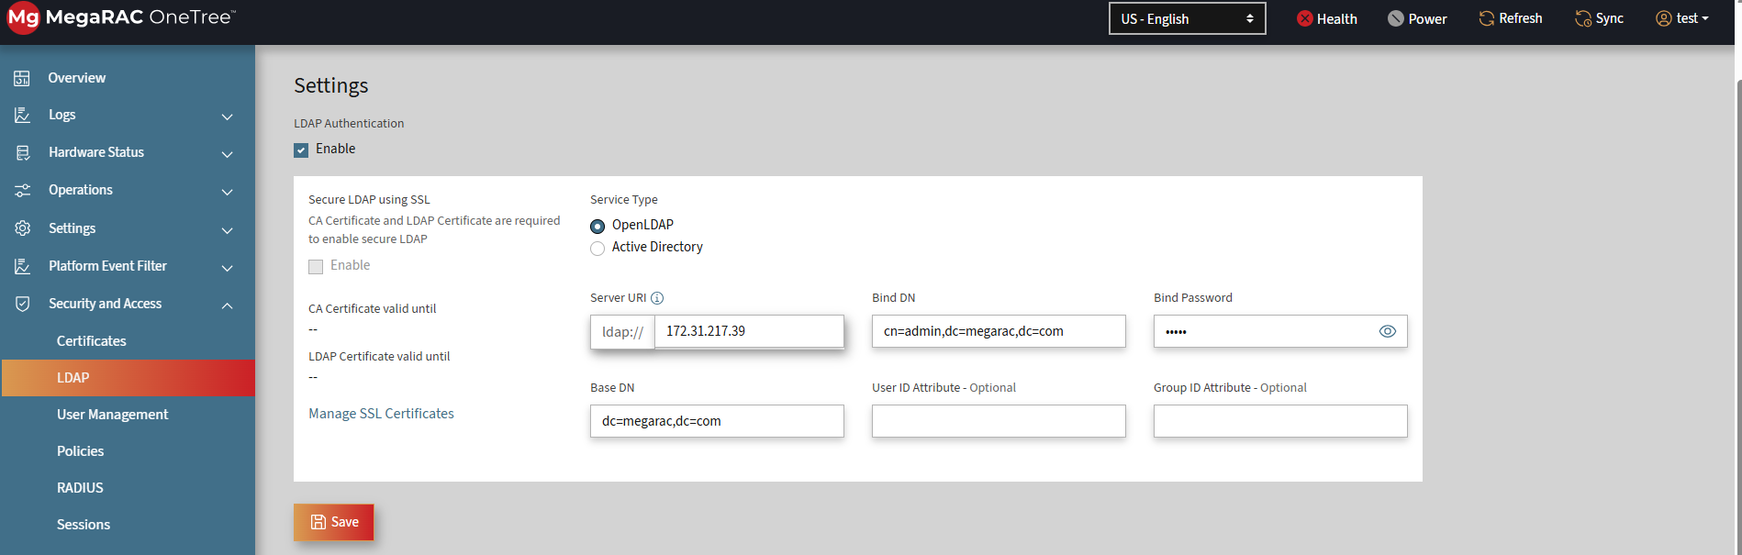
Step 3: After Filling the Details Need to create the Group with the provided information.
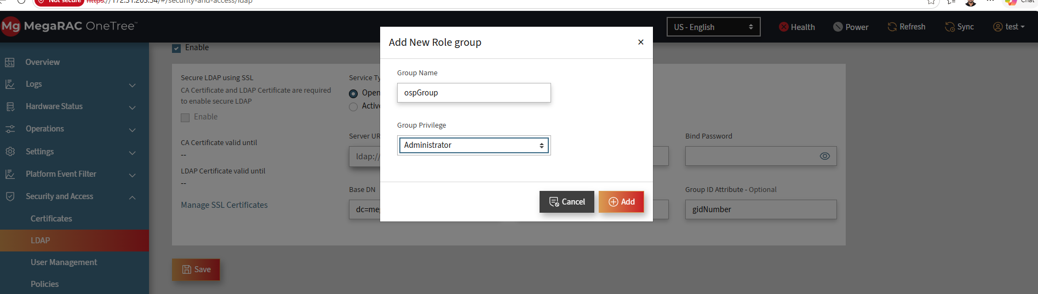
Step 4: After Creating the Group Need Login with Server username and password

7 Active Directory
To check the Active Directory Feature We need the get the Server details as follows:
Step 1: Need to create the New User As mentioned in the Local Feature and need to login with the new credentials.
Step 2: We Need fill the Above Server Details in the LDAP option with Active Directory option and need to Save the Details.
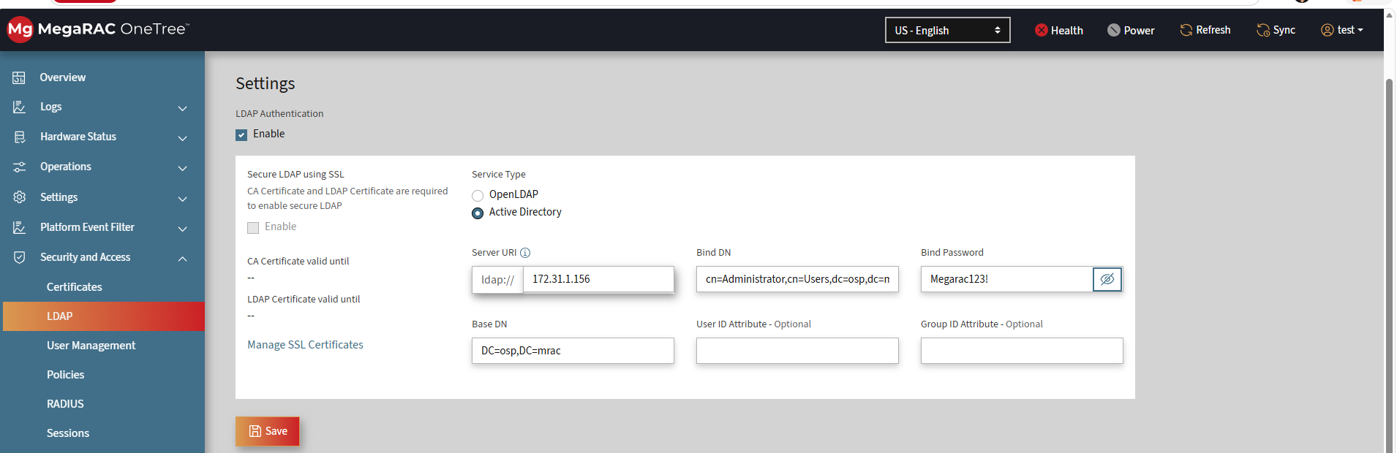
Step 3: After Filling the Details Need to create the Group with the information provided.
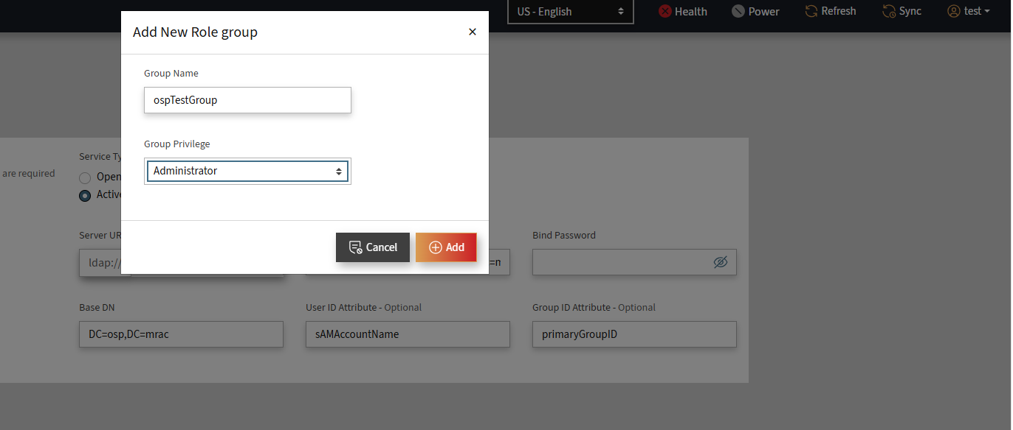
Step 4: After Creating the Group Need Login with Server username and password

8 IPMI FIREWALL
Step 1: Add an IPv4 Rule
Command:
ipmitool raw 0x32 0x76 0x00 1
ipmitool raw 0x32 0x76 0x02 192 168 0 10
ipmitool raw 0x32 0x76 0x03 192 168 0 20
ipmitool raw 0x32 0x76 0x09 1 0
Step 2: Verify Number of IPv4 Rules
Command:
ipmitool raw 0x32 0x77 0x00 0
Step 3: Verify First IPv4 Rule
Command:
ipmitool raw 0x32 0x77 0x01 0
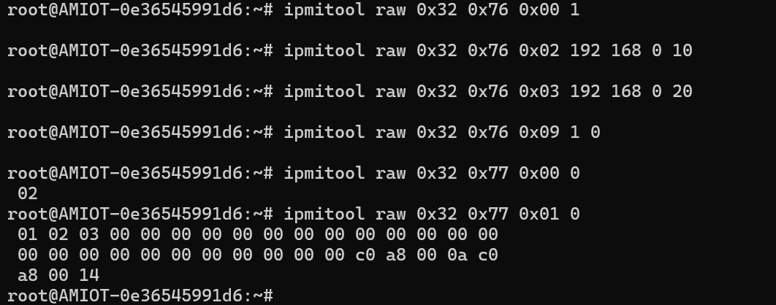
Step 4: Reboot the BMC
Command:
reboot
Step 5: Verify Number of IPv4 Rules After Reboot
Command:
ipmitool raw 0x32 0x77 0x00 0
Step 6: Verify First IPv4 Rule After Reboot
Command:
ipmitool raw 0x32 0x77 0x01 0
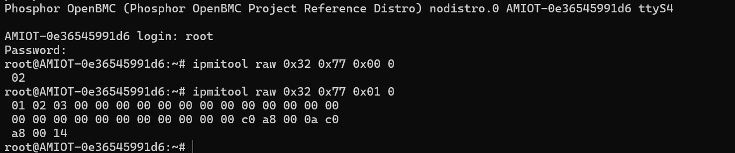
Result : Pass
CRITICAL PROCESS MONITORING SUPPORT
Step 1: ps | grep -i entity
Step 2: kill -9 < process>
Step 3: check again the process created. ps | grep -i entity
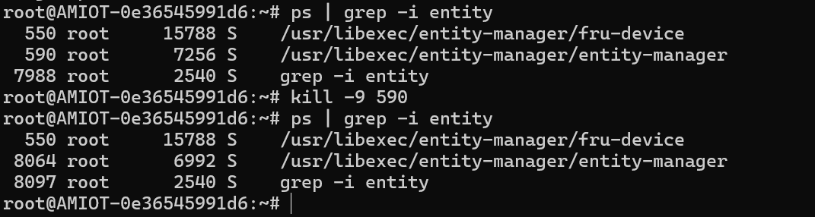
Result: Pass
BAND EXTERNAL CHANNEL SWITCH
Step 1: Check out of band ipmi command raw 6 1 working.
ipmitool –H <ip> -U root –P 0penBmc –I lanplus –C 17 raw 6 1
Step 2: busctl | grep -i Control
Step 3: Using busctl introspect Control Service Manager
Step 4: For etho change masked as true and check ipmi out of band command working or not.
ipmitool –H <ip> -U root –P 0penBmc –I lanplus –C 17 raw 6 1

9 Firmware Update
1.Login BMC Firmware Update cosole

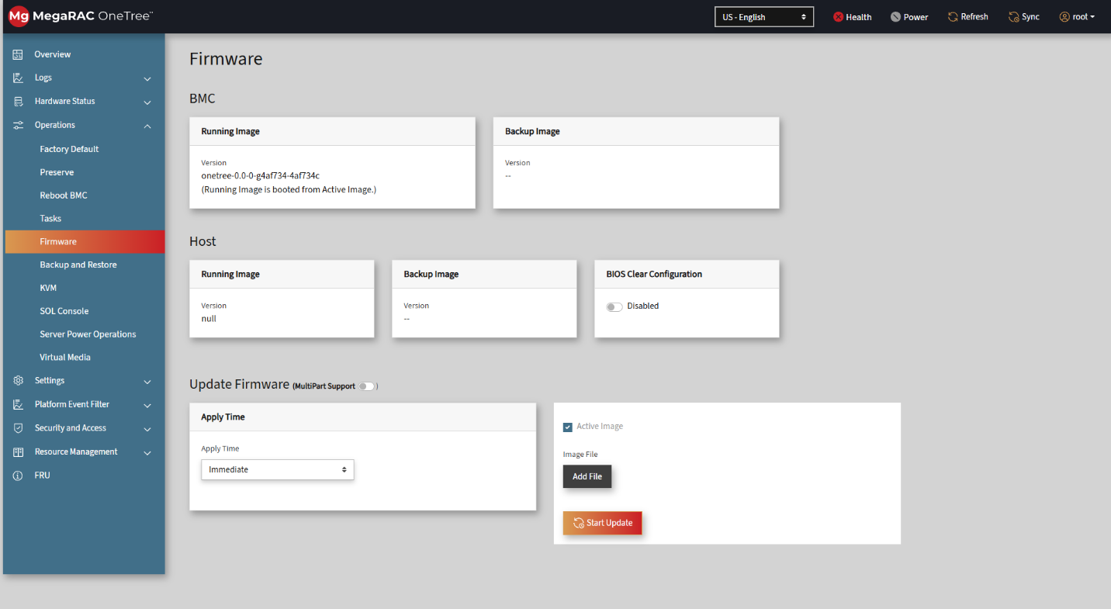
2. Login Web UI, navigate to Security and access → User management, add a new user with following settings:
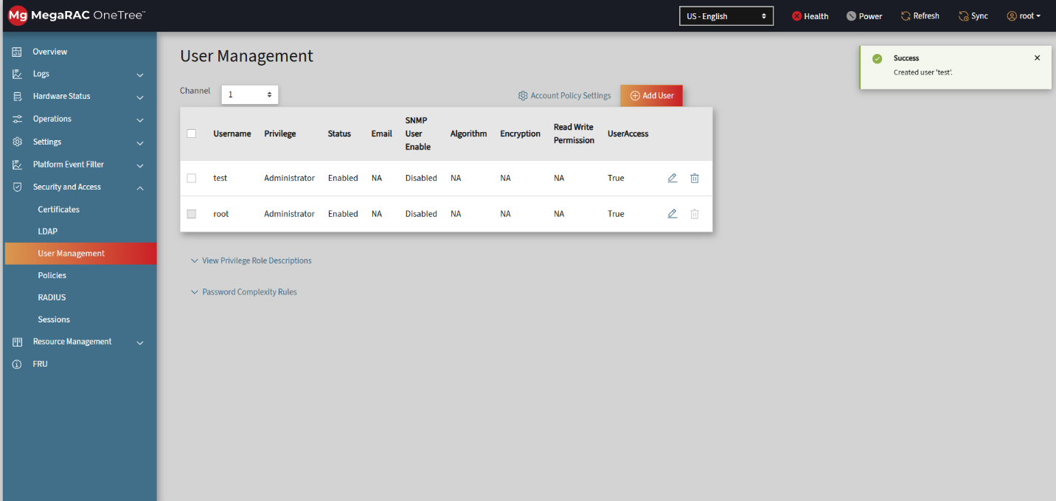
3. Navigate to Operations → Firmware Select Immediate for Apply Time, click on “Add file” to choose the firmware image (.tar.gz), then click on “Start”.
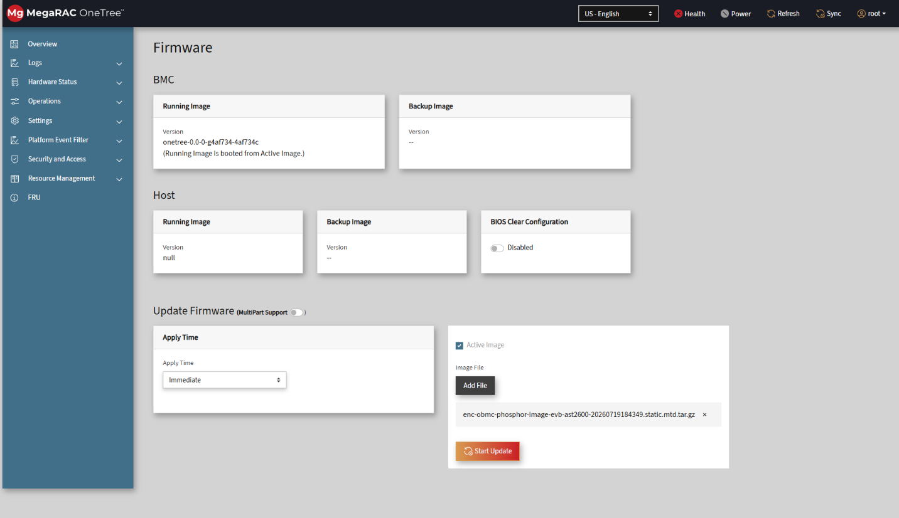
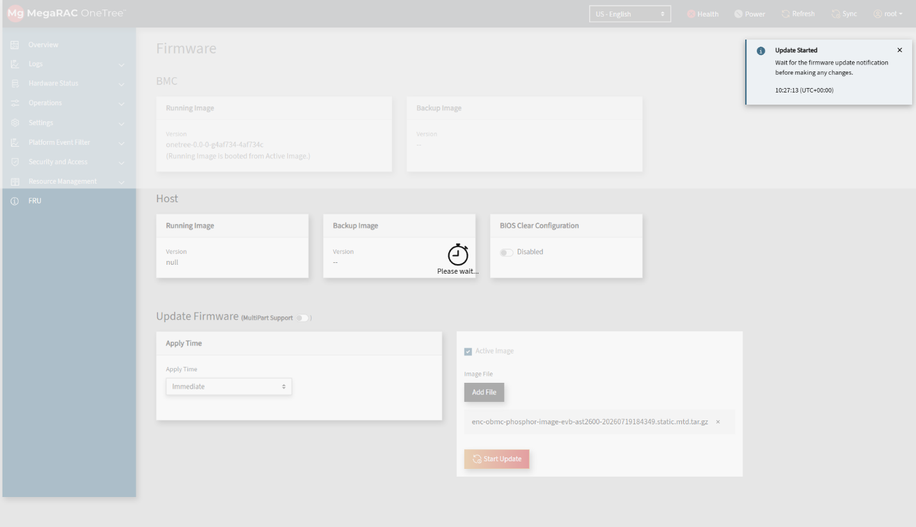
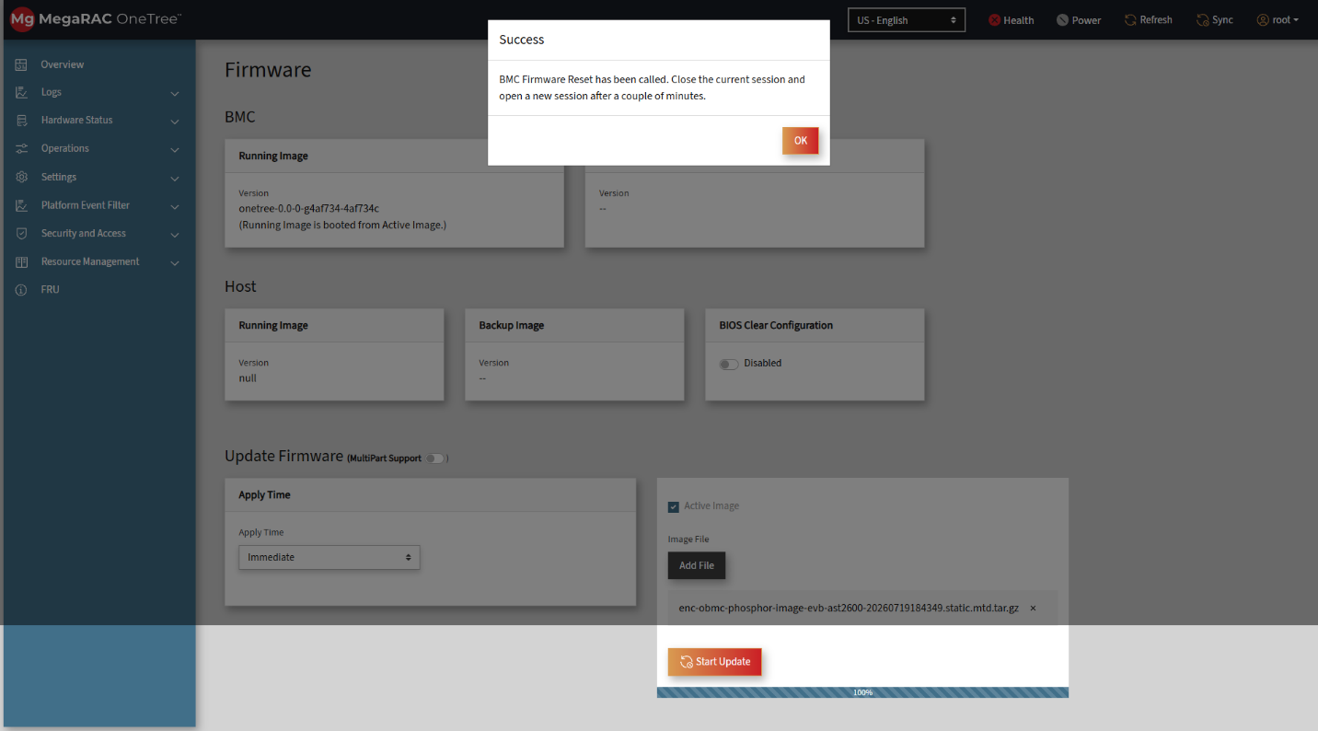
4. Login BMC console, send journalctl command to check fwupdate log
